# Abstract

The project is concerned with e-commerce. To do this project the resources are researched in a different approach. They are searching on the internet, watching the interview, and researching in comments on popular websites like amazon, and Alibaba. The goal of this project is to make a user-friendly website so that regardless of the well-educated customer or aged person can also buy the product if they like. Creating the website as simple and user-friendly as possible. The abbreviations and their meaning have been put to early understanding of the thesis. During the research, it is found that most people are likely to shop online. But some people are unable to buy the product due to the language barrier and are not so familiar with the technology. They should either give up or need the assistance of other people. In this project, I have tried to solve that problem. By reviewing a number of the article it was possible to determine the future potential new ideas and recommendations. Those ideas were applied in the coming website development.

# Acknowledgments

I would like to thank NIMS college and TU. Firstly for allowing me to do a project as part of my Bachelor in Computer Application (BCA) degree requirements.

I received great assistance and support from my teachers and colleague. I want to thank my teacher Ujjwal Bhusal for helping me develop an excellent idea for the study.

I would also like to thank my parents for their wise counsel and empathetic listening ear. You have supported me differently. Lastly, my friend has helped me a lot by giving me a break from my studies and a place to speak about my queries and the possible results.

# Table of Contents

Abstract 1

Acknowledgments 2

Table of Contents 3

List of Abbreviations 4

Chapter 1: Introduction 7

1.1 Introduction 7

1.2 Problem Statement 7

1.3 Objectives 9

1.3.1 Academic Objective   9

1.3.2    Technical Objective   9

1.3.3    Personal Objective   10

1.4 Scope and Limitation 10

1.5 Report Organization 11

Chapter 2: Background Study and Literature Review 12

2.1 Background Study 12

2.2 Literature Review 14

Chapter 3: System Analysis and Design 17

3.1 System Analysis 17

3.1.1 Requirement Analysis 17

3.1.2 Feasibility Analysis 19

3.1.3 Data Modeling (ER-Diagram) 20

3.1.4 Process Modeling (DFD) 21

3.2 System Design 23

3.2.1 Architectural Design 23

3.2.2 Database Schema Design 25

3.2.3 Interface Design (UI Interface / Interface Structure Diagrams) 25

3.2.4 Physical DFD 29

Chapter 4: Implementation and Testing 30

4.1 Implementation 30

4.1.1 Tools Used (CASE tools, Programming languages, Database platforms) 30

4.1.2 Implementation Details of Modules (Description of procedures/functions) 35

4.2. Testing  36

4.2.1 Test Cases for Unit Testing 36

4.2.2 Test Cases for System Testing 36

Chapter 5: Conclusion and Future Recommendations 38

5.1 Lesson Learnt / Outcome 38

5.2 Conclusion 38

5.3 Future Recommendations 39

Appendices (Screen Shots/ Source Codes/ Supervisor Visit Log Sheets) 40

Bibliography 57

# List of Abbreviations

|  |  |
| --- | --- |
| Abbreviations | Definations |
| DFD | Data Flow Diagram |
| XAMPP | Cross-platfrom Apache Mysql Php and Perl |
| HTML | Hyper Text Markup Language |
| Php | Hypertext Preprocessor |
| AJAX | Asynchronus Javascript And Xml |
| ER Diagram | Entity Diagram |
| JS | JavaScript |
| CSS | Cascading Style Sheetq |
| SQL | Structured Query Language |
| CRUD | Create Read Update Delete |
| DBMS | Data Base Management System |
| UI | User Interface |
| TU | Tribhuvan University |

# List of Figures

Figure 1 : Problem statement 1 8

Figure 2 : Problem statement 2 8

Figure 3 : Problem statement 3 8

Figure 4 : Objective 10

Figure 5 : Use-case 18

Figure 6 : ER-diagram 20

Figure 7 : DFD-1 21

Figure 8 : DFD 2 22

Figure 9 : DFD 3 23

Figure 10 : Architecture-flowchart 25

Figure 11 : Datebase-Schema 25

Figure 12 : UI-register 25

Figure 13 : Login-form 26

Figure 14 : Admin-page 26

Figure 15 : Admin-update 27

Figure 16 : Shopping-cart 27

Figure 17 : UI-index 28

Figure 18 : UI-product 28

Figure 19 : DFD-physical 29

Figure 20 : DFD-logical 29

Figure 21 : Database_connection_cart 40

Figure 22 : Datebase_of_user-type 41

Figure 23 : Database_product 41

Figure 24 : Database_user_cart 42

Figure 25 : Login_page 42

Figure 26 : Admin_page-CRUD 43

Figure 27 : Admin_page_delete 43

Figure 28 : Admin_update-page 44

Figure 29 : admin_page-after_updated 44

Figure 30 : Cart_code-php_code-i 45

Figure 31 : Cart_code-php_code-ii 45

Figure 32 : Account_php_code-i 46

Figure 33 : Account_php_code-ii 46

Figure 34 : Admin_page_php-code-i 47

Figure 35 : Admin_page_php-code-ii 47

Figure 36 : Admin_product_php-code-i 48

Figure 37 : Admin_product_php-code-ii 48

Figure 38 : Admin_update_php-code-i 49

Figure 39 : Admin_update_php-code-ii 49

Figure 40 : Configuration_code-php 50

Figure 41 : Index_php-code-i 50

Figure 42 : Index_php-code-ii 51

Figure 43 : Login_form_php-code-i 51

Figure 44 : Login_form_php-code-ii 52

Figure 45 : Login_from_php-code-i 52

Figure 46 : Login_from_php-code-ii 53

Figure 47 : Logout_php-code 53

Figure 48 : Product_code-php-i 54

Figure 49 : Product_code-php-ii 54

Figure 50 : Register_php-code-i 55

Figure 51 : Register_php-code-ii 55

Figure 52 : User_page_php-code-i 56

Figure 53 : Register_php-code-ii 56

# List of Tables

Table 1 : CASE tools 31

Table 2 : Programming tools 33

Table 3 : Test-case_unit 36

Table 4 : Test_case_for-system 37

# Chapter 1: Introduction

## 1.1 Introduction

Nowadays many websites provide online selling services on different variety line grocery, clothes, electronics, food, and many more. In this project, I am creating an online electronic shopping platform. This project will be user-friendly. The user-friendly interface will be there where any user who is familiar with the computer or not, can perform any function with a simple click. Other websites like gyapu and sahayogi display the content first but whenever the user enters the keyword, they like to see the display will be categorized according to the price, maker, functionality, durability, and so on. But on my project will be user-friendly because the comparison makes the user decide which product to buy according to their budget and need. In this project, I welcome comments or reviews of the customer under the community guidelines. Other websites take the customer comments and replies but I will consider them and make them implemented. For example, if I sell the product stating it will work for 6 months if it will not work, I will review the product and that error will not happen in the future.  My project will be user-friendly, user friendly in sense of that if any user searches for the product, it won't display all the products at once which makes the user more confused. But I will show a few products in the comparative display. No matter the user is professional or amateur, the user is young or old, the user is highly educated or not well educated but a simple reading and writing ability can shop easily and comparatively.

## 1.2 Problem Statement

The problem arises when any user visits the website and enters the keyword they like to buy. As a result, that shows many products list. Off Course, we can arrange the order according to the price high to low or low to high that only shows the product price rather than the functionality as well as the durability. And price only does not say that it fulfills the user's requirement. When a user who is a gamer buys a laptop at a high price there might be a mistake or judgment so that he buys a laptop at a high price but that is for the programmer. And same goes for the programmer also. Some customer buys any product like a mouse paying some price but he does not mention the role as a simple user, programmer, or gamer. There is thinking about how to increase the sell rather than increasing customer satisfaction.

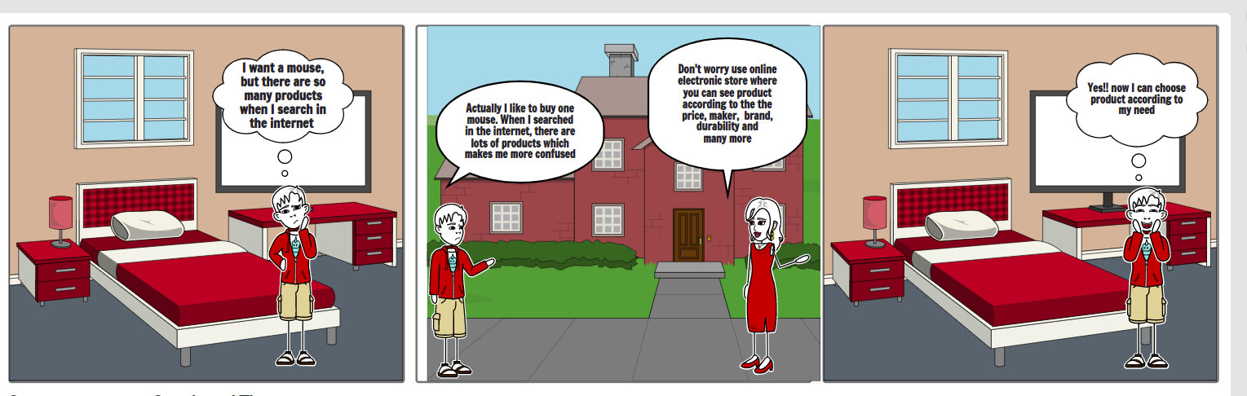

Figure 1: Problem statement 1

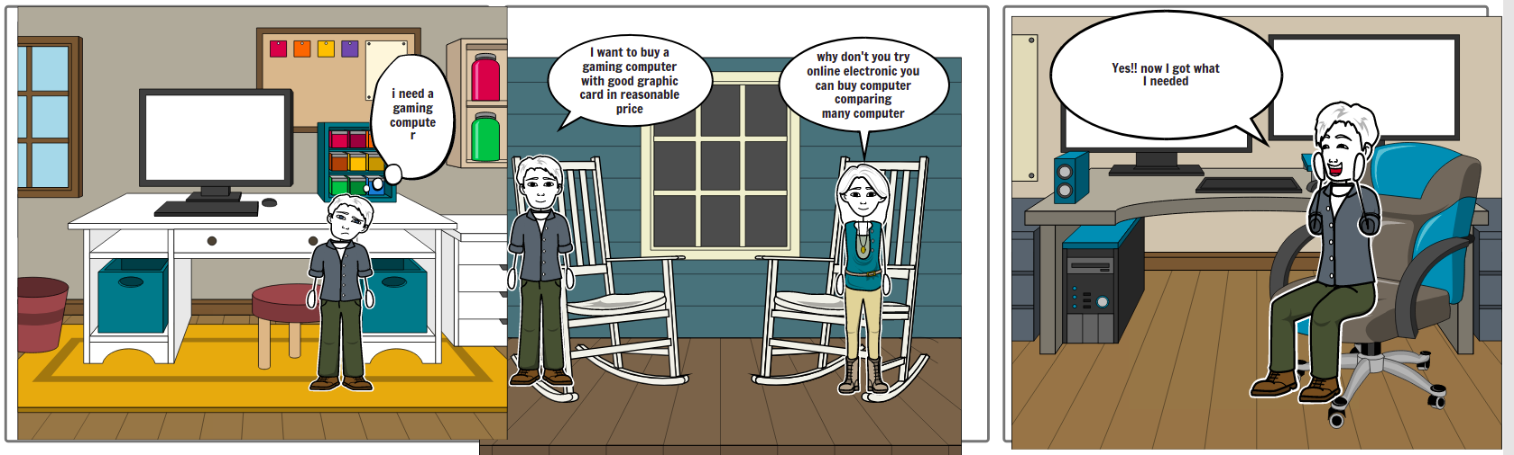

Figure 2: Problem statement 2

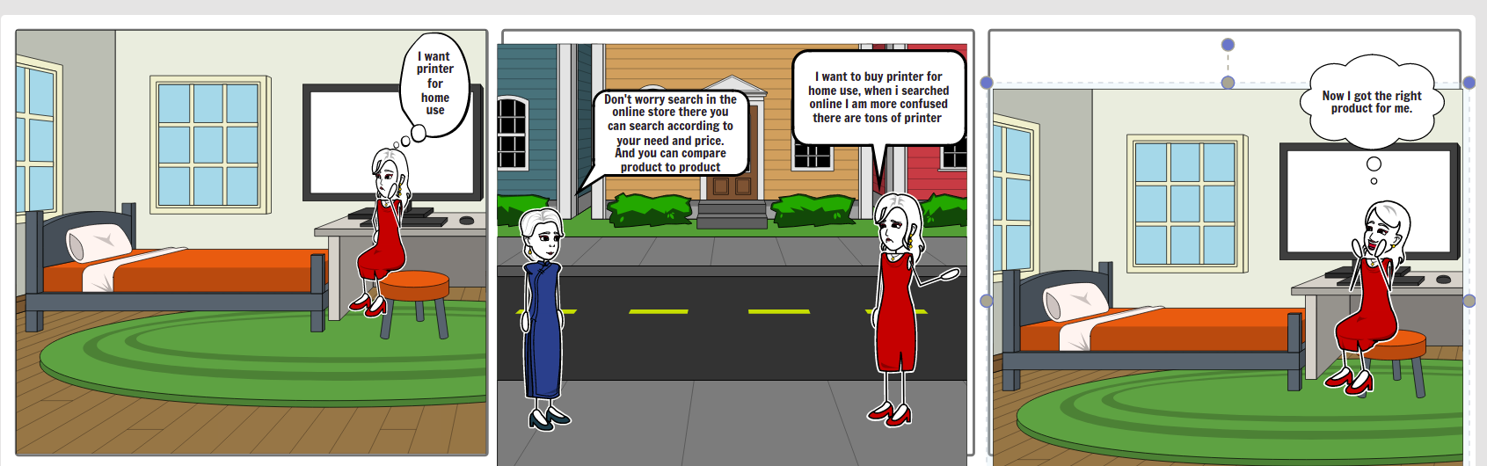

Figure 3: Problem statement 3

**Solution**

As I have mentioned the problem above, the solution to that problem is my website's online electronic store. Whenever customers visit my site, they will see the interface same as any other website. But whenever customers enter the keyword, the product is displayed, at this time my website makes difference from others. Because the product is displayed differently than on another website. The product is displayed according to its brand, price, durability, size, and many more. People usually get confused while selecting the product one by one by scrolling up, down, right, and left. On my website, there will be 5 or six products on one page. All of them are categorized by the product name, durability, price, brand name, size, and so on. In this way, the product can be chosen by the customer according to their need. A programmer is likely to buy a mouse with high durability, whereas a gamer like to buy a mouse that has multiple functionalities. On my website, amateurs, as well as professionals, can easily shop.

## 1.3 Objectives

The objective of the project on electronic e-commerce is that make an easy shopping experience on the web with trust.

Many people in Nepal have experienced online shopping but merrily they trust the site.

Saying that when we see the product on the photo is different and buying different time.

My project will try to tear the doubt of the customer.

My project is not about the one-time transaction but again and again.

Creating a good relationship with the customer virtually.

### 1.3.1 Academic Objective

* Creating own online shopping portal
* Developing writing skills where the description of the product should be attractive and meaningful
* Completion on the time
* Developing knowledge of the online transaction
* Knowledge of the customer behavior while doing online shopping

### 1.3.2    Technical Objective

* As a technical objective, get a chance of writing code on our own. Till now we studied but here we implemented practically
* Knowledge of the website how it works and the transaction process
* Knowledge of buying the domain and hosting on the internet
* Being used to laptops and the internet
* Knowledge of combining different languages like JavaScript, HTML, SQL, and many more

### 1.3.3    Personal Objective

* Gaining real-life experience on the IT related work
* With the completion of this project, it can be sold in the market also or with the help of this another online shopping portal also can be made
* Till now whatever we have studied we can put into practice also
* We can compete with other IT-related fields when we are graduated

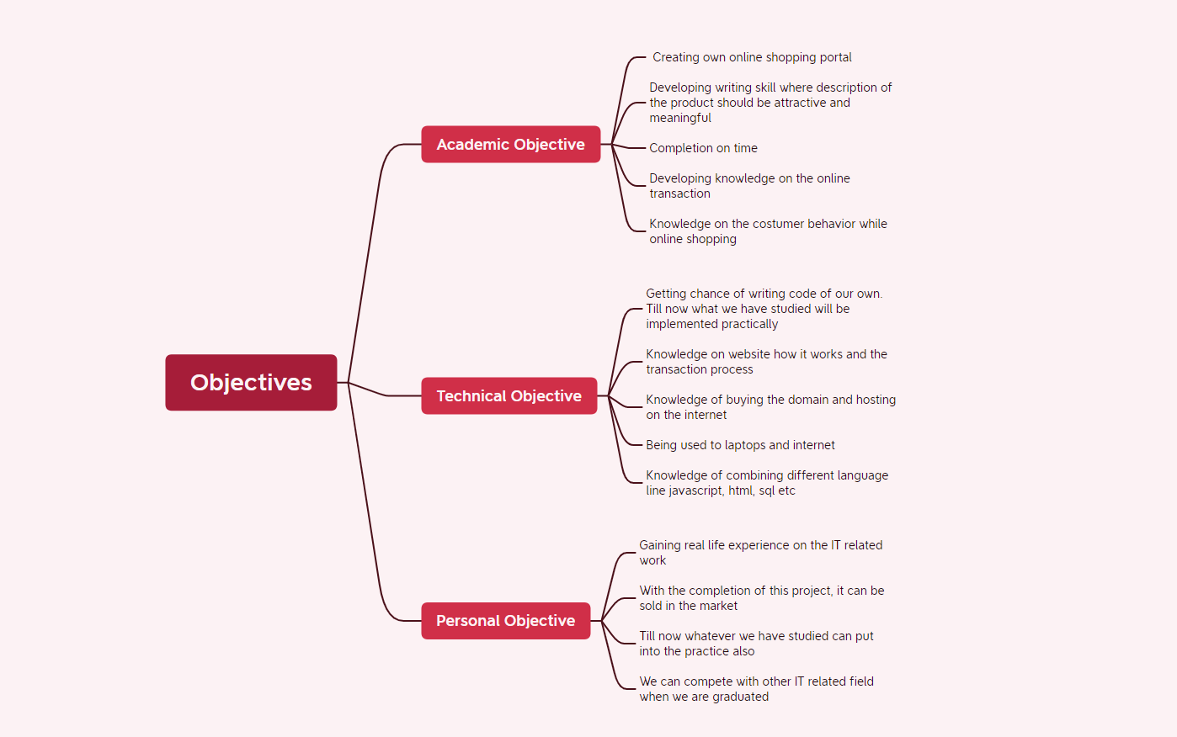

Figure 4: Objective

## 1.4 Scope and Limitation

The scope of my project will be the small industry and medium industries that are doing business in electronic items. Even a startup company can go for it.  Another scope is the office and educational areas. As I can make cash on delivery also many people who are not willing to put their information on the internet, I can address that customer also.

            The limitation of my project is adding the Nepali description to my products. I can add the description from the Nepali translator but it won't support by the text editor. And also, there is a limitation of the word that exactly matches the product description. Another limitation is trust, no matter how descriptive and cheaper the product is there is always an issue of trust. Users are likely to buy the same product at more than double the price but are not likely to buy the product online. Another problem of high labor cost may arise because there is not only selling of the product more than 5000 but at the time of selling the mouse which may cost around Rs 150, to make delivery of the product it may cost more than that.

Another limitation can be said to the legal issue till date government has not made any proper rules for the online transaction so any misconduct happens there are not any proper guidelines for that.

## **1.5 Report Organization**

The pages from the certificate page to is numbered in roman from page number 1. The page number should be inserted at the bottom, aligned center. The paper size corresponds to A4. The margin must be set as Top = 1, Bottom = 1; Right = 1; Left = 2.5.  All paragraphs must be justified and have a spacing of 1.5 and the content of the document should be in Times New Roman Font. The font size in the paragraph is 12. Font size for the headings is 16, 14 is for section heading, and 12 is for the sub-section heading. All the headings are bold-faced.

For electronic stores, in chapter one there is an introduction and background related to electronic the project where problem statements, objectives, scope, and limitations are mentioned. In chapter two there is a background study and literature review mentioned. I have made a comparison between the existing system and how my system differs from them. How my system will be user-friendly? In chapter three there is system analysis and design where requirement analysis, feasibility analysis, ER diagram, and processing modeling are shown. Among many existing systems in the market analysis is done on how feasible my system is and what the requirements are needed. I have researched on the internet and asked friends and family about the experience of using the existing system. In chapter four there is implementation and testing are discussed. Testing is done to see whether my system is fulfilling the requirement or not. If it is running error-free or not. In the implementation used tools case like CASE, Programming languages, and Database is shown. In the testing Unit, testing and system testing is shown. Last chapter 5 there is a conclusion and Future Recommendations is there. Where there is the lesson learned and outcome with the conclusion and future recommendations is there.

# Chapter 2: Background Study and Literature Review

## 2.1 Background Study

**Description of fundamental theories**

Online shopping was first introduced by English inventor Michal Aldrich in 1979, Aldrich invented the first form of e-commerce which allowed online transaction processing between seller and buyer 19. And the first web browser (WWW) was invented in 1990 by Tim Berner Lee which was the second major discovery. After the establishment of these two important factors. The expansion of online shopping is ready to trigger. In 1994 Netscape introduced an encryption-based internet security protocol called SSL (Secured Socket Layer) which was very important for the business. SSL makes sure that the personal information of the customer won’t be a leak to a third party. Due to this system financial transactions are possible. In 1995 Amazon.com was introduced by Jeff Bezos (the richest man in the world 2019). Then eBay.com break the monopoly of amazon. The marketplace was not reliable introduced PayPal in 1998 which becomes a quick success at the time. Because of the need. In 1999 Jack Ma introduced Alibaba.com in China which was a prominent Chinese marketplace 18. When we are approaching the 21st century Google launched AdWords, an advertising service that allows us to put an advertisement on Google search results. In simple words, google connects the seller to the buyer on a greater scale. In 2004 Shopify was introduced was helps low-capital sellers to set up online stores. That was a game changer now everyone has the access to the online store. In 2006 PayPal launched the payment system through the cellphone which made online shopping to the next level. Coming to 2020 it is clear that the entire internet has become a virtual online shopping center. Which was also followed by Instagram, WhatsApp, and Facebook. Loudly announcing we are in the online shopping era.

Before online shopping people go to the market and get the pamphlet in their hand and they choose the product. Also advertising the product is shown in the newspaper, television, radio, and many other means of communication. Before entering the online shopping era, it was hugely difficult to see the product and time-consuming. We can’t even imagine the effort we will put into shopping compared to the ancient era. Even to look at one product we need to go up to a marketplace, see the function, then price, and again buying and delivery. That was a huge mess and might take a day longer. Comparing now in a couple of minutes we can buy things and our product will be on the doorstep.

In the context of Nepal, e-commerce was introduced to distribute the gift to Nepali families, relatives, and friends who are living abroad. In the late 1990s, the shift from physical stores to virtual stores began 21. Mr. Bal Krishna Joshi, a co-founder of thamel.com claims that he has introduced the first ever e-commerce in Nepal. When a question arise, he said that he was in the US in the late 1990s when the advent of internet e-commerce companies like Amazon, and eBay were launched. While those companies were growing, he thought to do same in the Nepal also. Executing this idea in 1998, he started thamel.com as a business-listing website 1. That aim for globalizing and digitalizing the business of the shops are located in the Thamel. After that various Thamel shops came and started to register their shop by taking some amount of fee as a registration fee. For buyer and seller communication there was a chat platform also. At that, international call was really expensive at the time to chat played an important role in communication between the buyer and seller. After the launch of the website the first digital platform for shopping everyone was happy as well as excited. The company takes a good rise after the year of its establishment. But in the second year, the business did not go well because the registered seller do not want to continue. Because their business has already taken height and the seller doesn’t want to continue with thamel.com 1. Simply they don’t want our help which leads to a hard hit of financial problems. But unexpectedly people who are living abroad are using our chat platform to communicate with family members. Due to this, we realized that it would be great if Nepali from abroad would send a gift to Nepal on the occasion of Mother’s Day that did not go as expected. At that time there was no infrastructure for e-commerce in Nepal then. At that time, he was thinking of quitting it but some of his friends suggest to me that on the occasion of the Dashin we could send a goat to our home. We did not get any orders so we give advertisements on nepalnews.com then we received many orders 2. That led to a business of 50000 dollars. The payment was made by the Nepali people who are abroad. The business of selling goats was on the national international media also. Then after that selling of cake, fruit, and vegetable started in 2006. After that, we started digital remittance which was profitable. After that muncha.com was launched first online department store in Nepal in 2010 3. This site was used by Nepali who live in UK, USA, and Australia to gifts who are in Nepal 4.Soon after that many e-commerce came to launch. After that one after another company started like thuloMarket on 2007, 5 Foodmandu on 2010, Sastodeal on 2011 6, and many others. Soon after the launch of the eSewa in 2009 which is the first payment gateway in Nepal other services like Khalti, IME Pay, and many more start to evolve 7. That plays a vital role

in the growth of e-commerce in Nepal.

E-commerce has not limited to online shopping only but it is divided into many forms like food, banking, and ridesharing.8 One of the top-rated e-commerce in Nepal is pathao. In this app user select the destination location and present location then he selects a ride car or bike. That’s all we get our service it is very easy. Patho serves its service from door to door.

As many e-commerce sites are increasing day by day, the complexity is also increasing for example if we want to buy a simple mouse. Like in 9 GSMArena and Laptopmag they display the product by spec and many categorical differences but they are not e-commerce platforms 10. But in my project, the description is shown in real-time whereas other website shows the detail when clicking on the product. But in my project, the display is descriptive way as the user searched for the product. Then we search in an online portal by typing ‘mouse’ the result will display showing hundreds of computer-mouse which will make more confusing to the customer. So, in my project, I have developed the feature of displaying the product descriptively. Where result will show the product in a limited number which is 5 to 7 and the display is separated according to the product name, price, durability, functionality, brand, and many more. So that whenever the customer chooses a product he can choose according to his perspectives like price, durability, brand, or anything.

## 2.2 Literature Review

1. Rashesh Vaidya (2019) has explored in this study, that online shopping is increasing in Nepal rapidly because of the cost reduction on the internet, easy access, time convenience, easy payment, and user-friendly 11. In the context of Nepal, there are B2C (Business to Customer), C2C (Costumer to Costumer) and there are social network services like Facebook, and Instagram also. In Mr. Vaidya’s report, he has taken a report of 300 people who have used online shopping twice on the same platform. And he has mentioned that in Nepal the major challenge on the online shopping portal is the quality product and wrong products. The order that the customer sees on display does not match with the order they bought. And another challenge is the wrong product at the time of purchasing. Online shopping is booming day by day with the experience of 4G and 3G. So, the competition between the online portal is increasing rapidly which is ultimately good for Nepal technologies. The number of new entrepreneurs is increasing day by day. In the context of Nepal, starting 3 www.munchahouse.com made a way of shopping online accessible which is glamorous within Nepal and outside Nepal. But that was impossible at that time. After some time munchahouse.com changed to muncha.com for a short period. They introduced photo sites in 2002. After the influence and arrival of the latest technology comes to Nepal from the neighboring countries Nepal steps on the path to success through e-commerce. Online shopping takes the market with the help of 3G and 4G in the market. Another factor is the online payment like e-Sewa, Khalti, and IME pay introduced which added extra spice to the Nepali market.

2.Dr. G. K. Deshmukh and Dr. Sanskrity Joseph (2016) have explored in this study, traditionally people touch and feel the product before purchase whereas in online shopping product is seen visually only in this research both are researching the behavior of the consumer while shopping online 12. The ancient principle of “Vasudev Kutumbkum” practiced marketing through technology where marketing means geographical land mass where buyers and sellers meet for exchange of things of value. The value of things is compared with the internet. The term internet is defined as the art of selling a product in a virtual market by the mean of digital media. It is not selling virtually only but it means understanding the concept of WWW (World Wide Web) and properly using it for the merit of market and trade. The cellular companies in India made a strategy for lowering the cost of internet for the virtual world by increasing the customer.

3. Gholam-Reza Zandi, Rezvan Rorabi, Mohammad Amin Mohammad, Xu Yi Dan (2021) has explored that due to the development of IT (Information Technology) in China to catch an unprecedented pace 13. With the development of eCommerce in line with online shopping, online service has become an important part of life. This study examines customer satisfaction in the context of China on online shopping behavior. The data has been analyzed and collected through e-mail and the survey. The result shows that validity and reliability, Pearson correlation, and multiple Regression analysis show that online shopping websites' rules for privacy, delivery management system, and service quality factors improve customer satisfaction in China. The companies in China are carefully developing the E-commerce environment in terms of customer behavior and satisfaction. According to the research, 46.03% use the internet and among them, 21.97% are from China among the world. From the research of Internetlivestats.com 2015, it is shown that the total number of internet users is about 649 million which means an increase of 4% from 2013. The researchers suggest that the internet users in China are larger than in the USA and Russia.

4. Mohammad Anisur Rahman, MD. Aminul Islam, Bushra Humyra Esha, Nahida Sultana, and Sujan Chakravorty (2018`) have explored that online shopping is the better option in today’s busy world. In the past decades, we can see massive changes in the world and the same goes for Bangladesh also 14. It is said that e-commerce is a more than 2.29 trillion-dollar market (2018, eMarketer) and is expected to go up to 4 trillion soon. Asia Pacific region has made massive growth online specifically in China constituting about $899 billion (marker, 2016). Same like other young Asian people, Bangladesh is also practicing shopping in a new way to lead the popularity and growth. The main objective is to serve the good product and services to the consumer needs. The business that meets customer satisfaction. Moreover, in the context of Bangladesh online shopping has evolved rapidly and has the potential to expand exponentially in the coming time. Access to the internet has reached wide across rural areas.

5. Daraz, Business Company Studies, Nepal is one of the most popular online shopping brands in Nepal 16. It is one of the leading platforms in Nepal in terms of e-commerce. This is the portal that brings the revolution to Nepal in the field of e-commerce 15. It is one of the branches operating in Nepal like other countries. It has focused on those areas where there is no international e-commerce platform like Amazon eBay. The e-commerce sector has introduced many changes in terms of action and approach. Daraz was previously known as ‘Kaymy’ which was founded in 2014 in Nepal. This site can be accessed through ‘kay-mu.com’. Later it was acquired by the leading e-commerce business in South Asia ‘The Alibaba Group’ in April 2018. Daraz has many sources of market environments, sales growth, and returning consumers. It has over 30,000 sellers and 500 brands serving over 5 million customers across the region. It is highly successive in the context of Nepal. It has practiced three models which are B2B, B2C, and C2C. Every day more than 75000 visit the site and transactions are made over the thousands. Daraz offers huge discounts on many products on many occasions and events. For Example, Black Friday, Weekend special, Season Special, 11:11 Mega Sale, and many more. These are one of the strategies of their business. In this way, Daraz Nepal has been able to hold its position at the top though there are many e-commerce platforms in Nepal. Daraz has been able to overcome its competitors like shopmandu.com, sastodeal.com, gyapu.com, hamrobazar.com, etc because it provides those products which are not available on other sites. It is estimated that Daraz is of 50 million dollars and increasing. It generates a yearly estimated over a million of Rs. 3.55 billion and monthly about Rs 100K from sales only. According to the report, Daraz Nepal generates about Rs. 300 million in revenue from its 11:11 event alone. Daraz has expanded its coverage in almost every part of Nepal irrespective of the geographical condition. Daraz has provided job opportunities for thousands of Nepali people and even the delivery partner ‘Aramex Nepal’. Nepal is a developing country having potential in the field of e-commerce, many platforms like Daraz are trying their best to thrive in the market.

6. Dimitri Weidili (2013) has explored that since the starting of the internet in the 1990s there has been a rapid change in online shopping in the United States of America 17. Online shopping, as well as the online retail industry, keeps growing proportionally. Many people are investing through pure online retail as well as click-and-mortar retailing. These people have a face-to-face experience with the customer. 4.7% of the total retail trades in 2011 of online shopping which represents growth in the United States. And estimates to grow up to 10% on average and annual growth of 9%. Both online and traditional retailers have a different chain to fulfill their customer demands. When there is an order warehouse has to keep a sufficient amount of product in multiple outlets. Each outlet should have enough products to meet the demand. They made delivery by a big freight truck using the pallet. But online stores could be anywhere to fulfill the retail store. With the help of the data center information is sent when the consumer buys the product. Each product is packed and delivered to the address. According to the customer’s choice, the delivery is made by air or truck. Finally, the delivery is done by the optimized delivery route of different customers.

7. Amazon, amazon is one of the largest companies in the world and the CEO of Amazon Jeff Bezos richest man in the world 18. Amazon is a company that became the world’s largest in just 26 years like Apple, Google, and Microsoft. In 1994 Jeff Bezos started his own company named Cadabra. He read a report on the future internet that shows annual growth of 2300%. So, he decided to build an online company. As a result, Cadabra was born. Firstly amazon was exclusively selling books on the internet with more than three million titles for sale and available throughout the world, the number of categories of the book was more than any other. At the same time, he decided to change the name from “Cadabra” to “Amazon” because amazon is associated with the river and there is an alphabetical letter ‘A’ to ‘z’. As the amazon slogan is from A to Z. Bezos decided to sell books over the web, due to the large worldwide demand for literature, the low price that could be offered for books, and the greatest selection of titles that were available to print. Amazon.com's website was built on July 16, 1996, which results from the exponential growth of the company and its presence in the company. An amazing fact is that after Amazon.com it was selling books all over the 50 States and 45 countries. Bezos wanted to build the website as user-friendly as it can and can be related to all types of customers. The company offered many features like discounts, affordable prices, offered topics, recommendations, and many more. Soon after the big growth of the company, a new company named “Walmart” stole the idea. Amazon went public offering shares for $18. The business plan of amazon was unusual and unexpected so the company did not make a profit until five years. That makes investors unhappy because the investment does not justify the profit which was not good for long-term survival. In 2000 the company took a turnaround transforming itself into a marketplace that allows the user to find and sell a variety of products and services online with the highest level of quality and guarantee in the market. Entering in 21st-century amazon adventured to take another big step in relentless evolution. In 2002 amazon started AWS which gives services like storage, network, databases, application services, messaging, artificial intelligence, and many more. AWS has a presence in 190 countries. In 2005 it launched the Amazon Prime service; it allows selling the product directly to the customer as well as the third party delivering free if it exceeds 48 hours.

# Chapter 3: System Analysis and Design

## 3.1 System Analysis

In this project, we have followed waterfall methodology as the feature and module are defined and the project is also small. Here we have created the index page for the first view. There are pages like account, cart, login/register, and home. First users have to log in or register according to the role. That can be the user or the admin. As the admin, he/she can add the product, delete the product and update the product. As the user, they can buy the product added to the cart and click the pay now button.

### 3.1.1 Requirement Analysis

**i. Functional Requirements (Illustrated using use case diagram/list)**

The above figure depicts that first the user/admin goes to the home page he/she can see the simple layout of the website. Then according to the role user can register as the user type as the user. If the admin he/she can register as the admin. After that login is required, once the login is successful different operations can be performed. Admin can add the product, delete the product, or edit the product. Users can see the product add the product to the cart and buy the product by clicking the buy now button.

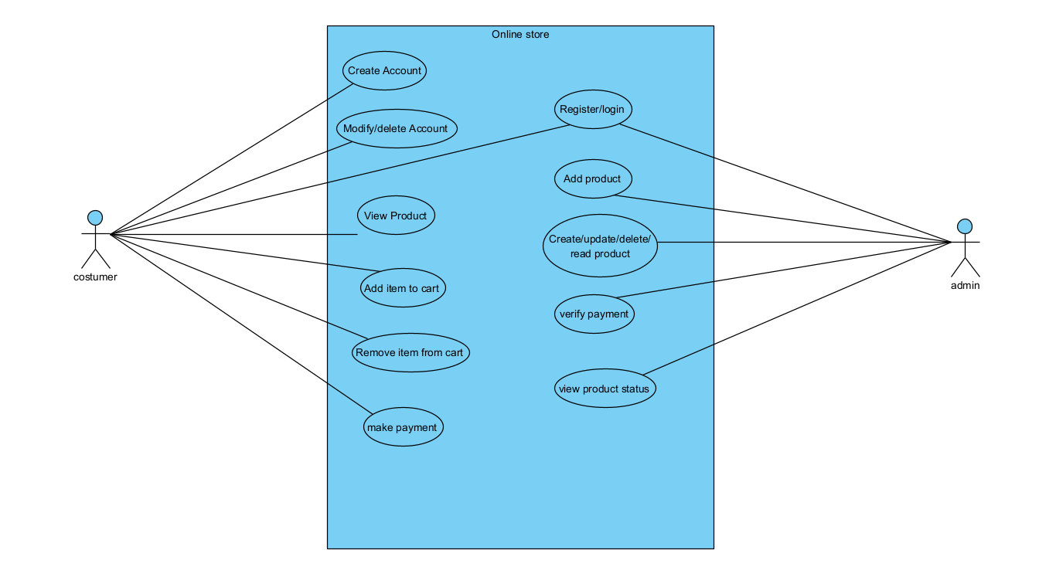

Figure 5: Use-case

* User can create account
* User can modify/delete account
* User can view the product
* User can add item to the cart
* User can remove item from cart
* User can make payment
* Admin can register/login to the system
* Admin can add the product
* Admin can perform crud functionality
* Admin can verify the payment
* Admin can view product status

**ii. Non Functional Requirements**

For better user experience over the system, we have added non-functional requirements like adding a home page on every page so that if any confuse or doubt regarding the product is there direct navigation to the home page is there. For user enhancement products and their description are arranged in the table so that users can buy according to their requirements. If he wants to buy a product according to the price or brand.

### 3.1.2 Feasibility Analysis

**i. Technical**

* As a technical objective, getting a chance of writing code on our own. Till now we studied but here we implemented practically
* Knowledge of the website how it works and the transaction process
* Knowledge of buying the domain and hosting on the internet
* Being used to laptops and the internet
* Knowledge of combining different languages like JavaScript, HTML, SQL, and many more

**ii. Operational**

* For operational feasibility, we see what kind of operational cost it may require.
* For the initial installment, we see how many people should separate for the technical assistance.
* We check for the backup data in case of loss.

iii. Economic

* In economic feasibility, we check how economically feasible is the project.
* We check that after the completion of the project we make a profit.
* We here check how economically strong are we.

iv. Schedule

* In schedule feasibility, we check that are we completing the project in time. We check the module also whether we are completing the module as per schedule or not.

### 3.1.3 Data Modeling (ER-Diagram)

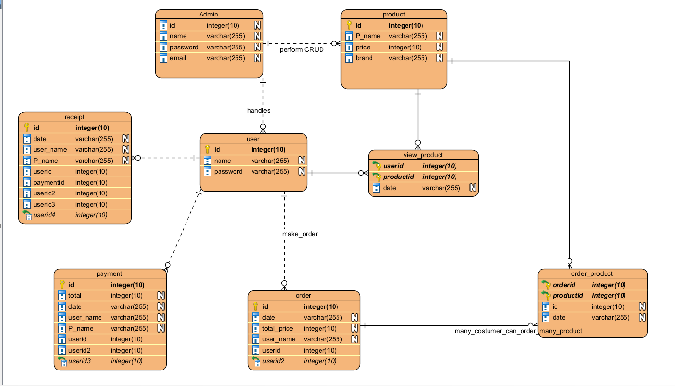

Figure 6: ER-diagram

### 3.1.4 Process Modeling (DFD)

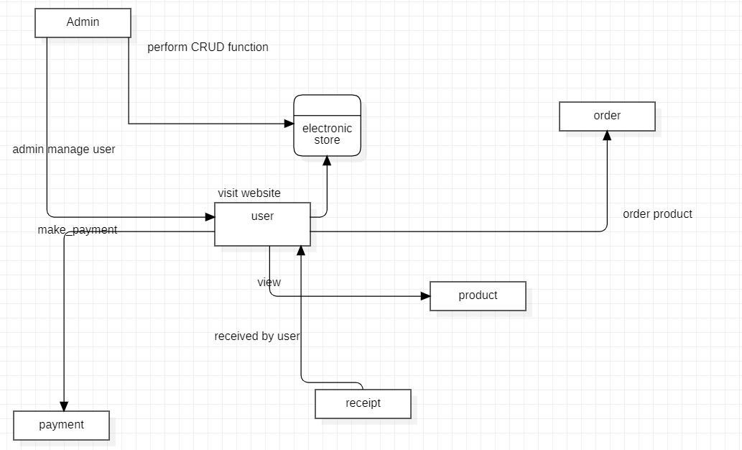

Figure 7: DFD-1

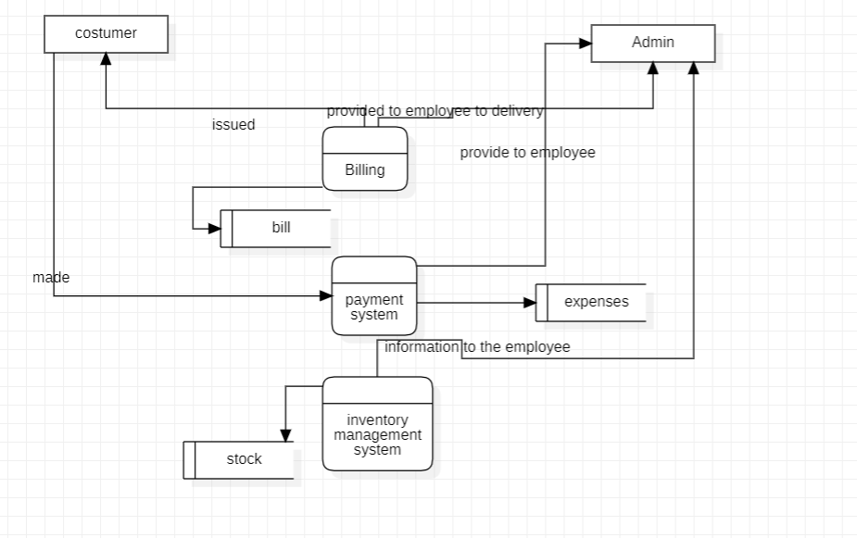

Figure 8: DFD 2

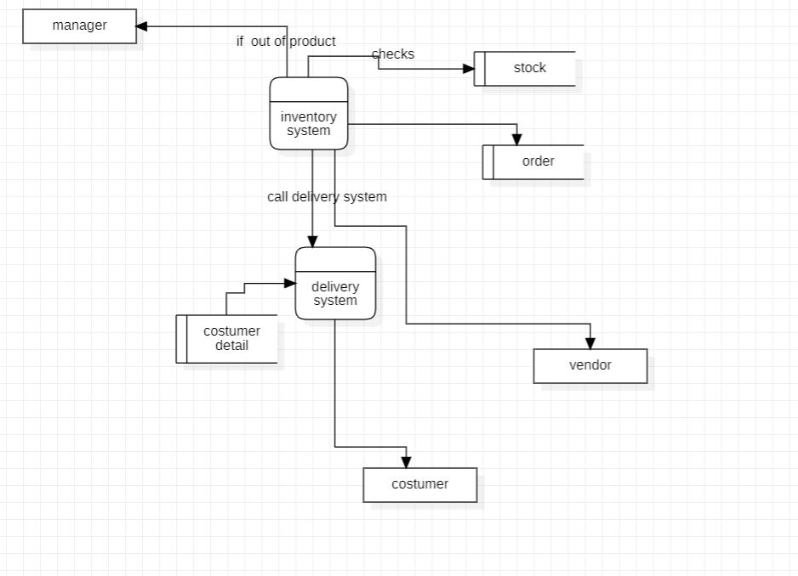

Figure 9: DFD 3

## 3.2 System Design

### 3.2.1 Architectural Design

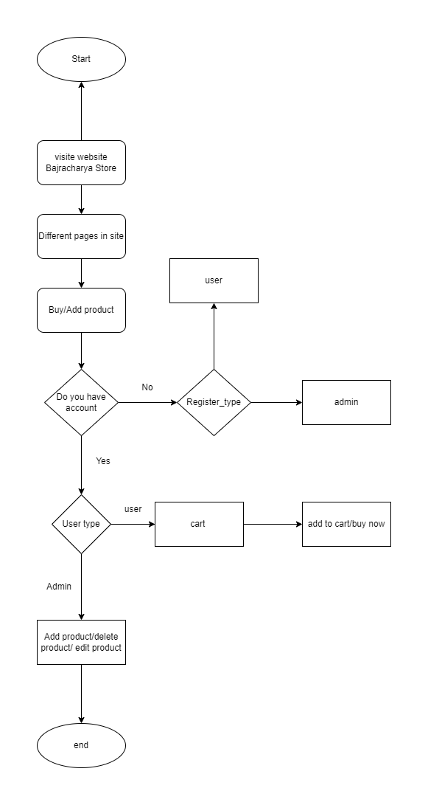

Figure 10: Architecture-flowchart

### 3.2.2 Database Schema Design

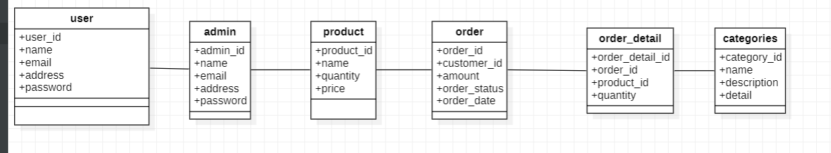

Figure 11: Datebase-Schema

### 3.2.3 Interface Design (UI Interface / Interface Structure Diagrams)

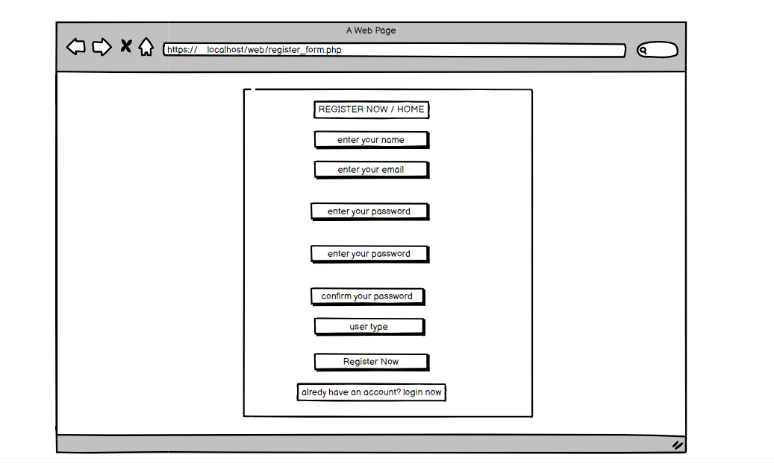

Figure 12: UI-register

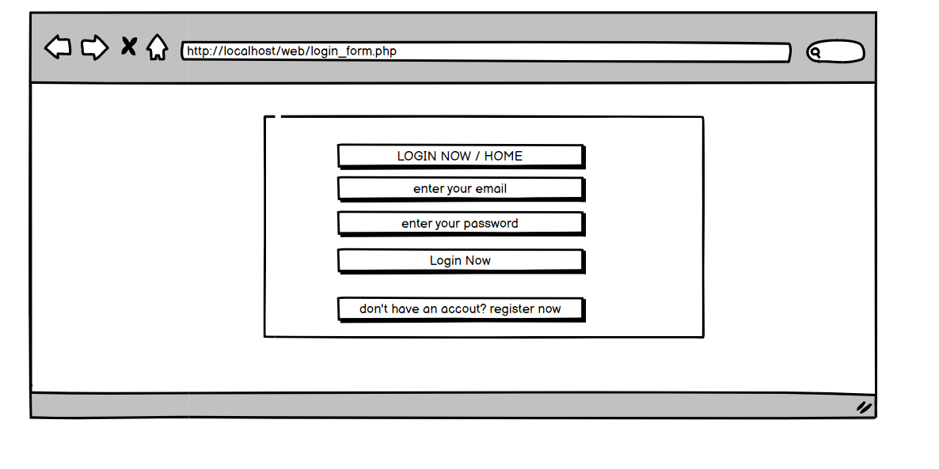

Figure 13: Login-form

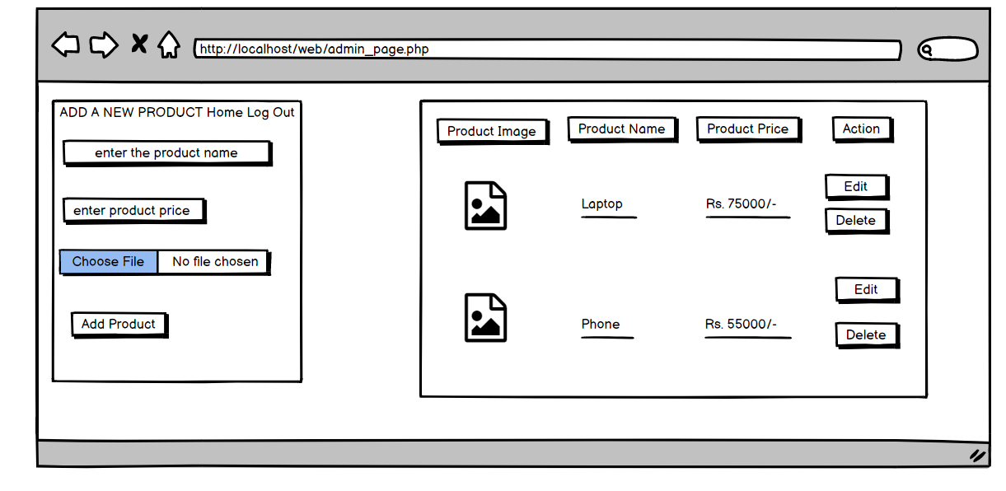

Figure 14: Admin-page

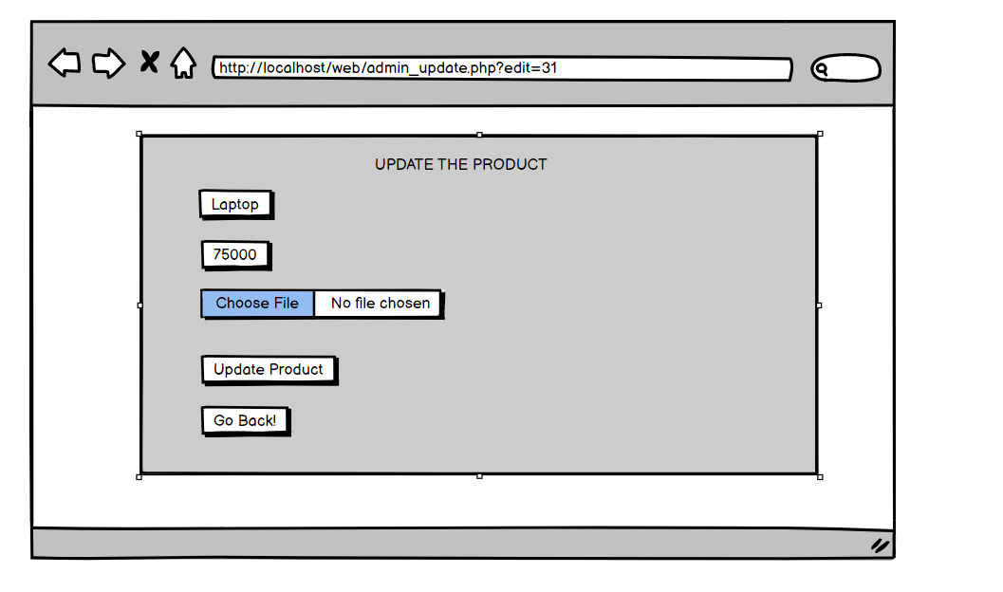

Figure 15: Admin-update

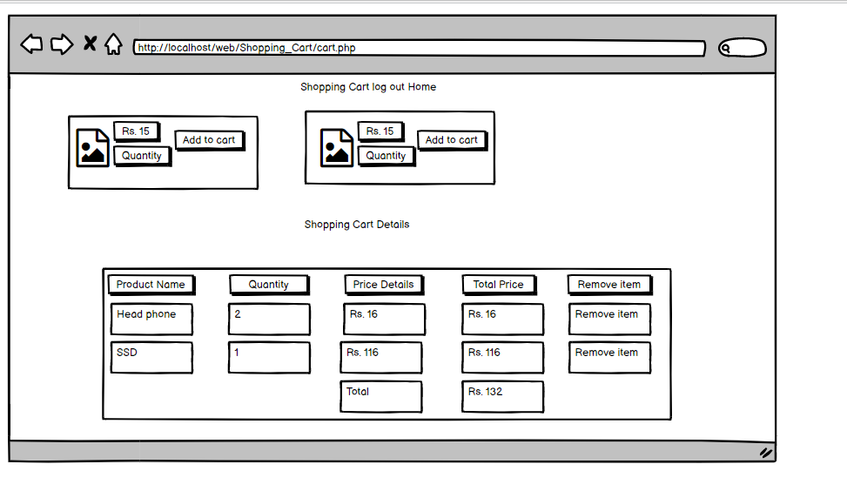

Figure 16: Shopping-cart

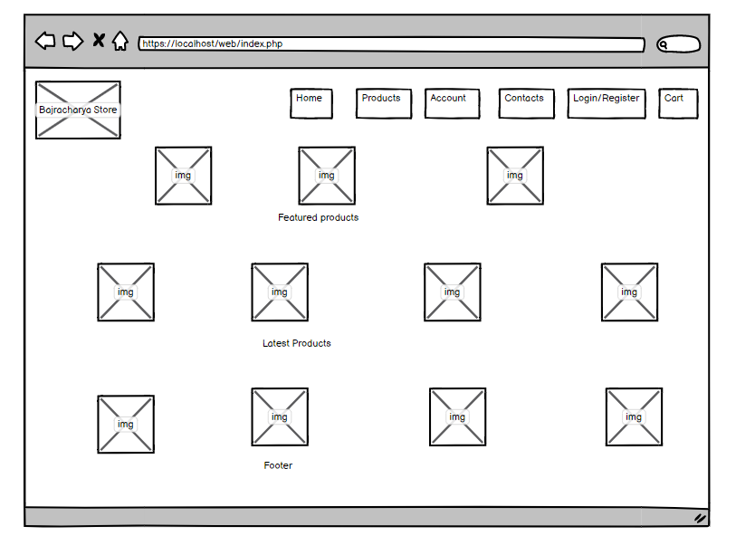

Figure 17: UI-index

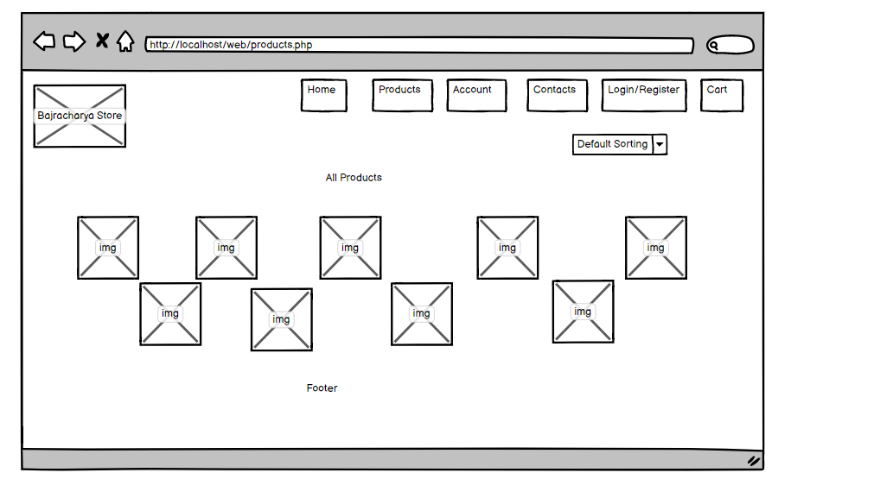

Figure 18: UI-product

### 3.2.4 Physical DFD

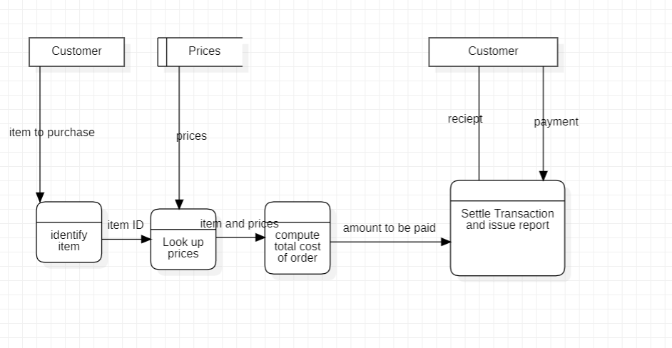

Figure 19: DFD-physical

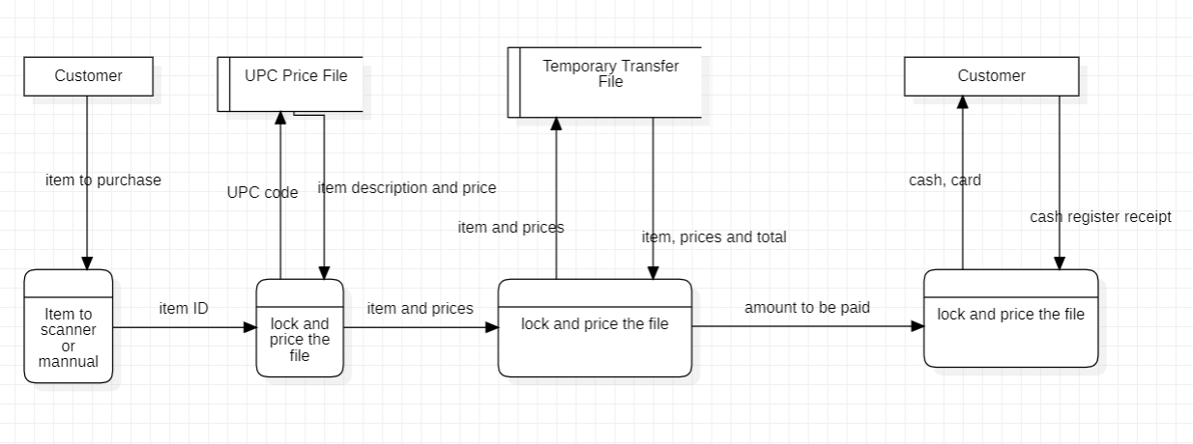

Figure 20: DFD-logical

# Chapter 4: Implementation and Testing

## 4.1 Implementation

### 4.1.1 Tools Used (CASE tools, Programming languages, Database platforms)

**CASE TOOLS**

|  |  |
| --- | --- |
| Used for | Tools and technologies |
| Analysis Tools |  |
| Design Tools |  |
| Programming Tools |  |
| Prototyping Tools |  |
| Maintenance Tools |  |
| Diagram Tools |  |
| Process Modeling Tools |  |
| Project Management Tools |  |
| Documentation Tools |  |
| Configuration Management Tools |  |
| Change Control Tools |  |
| Web Development Tools |  |
| Quality Assurance Tools |  |

Table 1: CASE tools

**YouTube**



Youtube is the online video sharing and social media where people upload their videos. And other people see the video according to their needs. There are many genera like education, entertainment music and many more. Here I have used YouTube for the research purpose that how are we (Nepal) using an online store and how at the international level they are using an online electronic store.

**Chrome**



Google Chrome is the search engine to access the world wide web. It is open source program. Google Chrome was introduced in 2008 and updated annually. I have used google chrome to do research like how many people in Nepal are using online shopping and at the level international. I see the result that how many people buy the product once they visit the website. What is the ratio of buying the product and not buying the product? I have compared the behavior of the Nepali society and the international level society and how they are reacting to the online store.

**Edge**



Edge is also the same as google chrome but the difference is that it is released by Microsoft. It was first released in 2015. I have used edge for research purposes but I have preferred google chrome over the edge. But sometimes whenever I have not found the result I have seldom used edge.

**Microsoft word**



Microsoft word is the documentation software used for writing reports, letters, resumes, and many more. It is one of the Microsoft packages that comes when we buy Microsoft office. I have used this word for creating the table, and paragraph in an organized way. It also helps me to find out the grammatical error and the word condition.

**Powerpoint**



It is one of the Microsoft office packages which help us with the presentation. I have used this for the presentation at the time of proposal showing what is the past condition of the online store in Nepal and the present situation. This depicts how exponentially is increasing the use of online stores. By using PowerPoint I have created a small presentation to show the condition of the online store.

**vscode**



It stands for visual studio code. It is IDE (Integrated Development Environment). It provides us with many tools for software development tools and one graphical user interface. In VSCode we can code any programming language like python, c, c#, ruby, and many more. I have used this for easy coding and this provides me with many tools. From VSCode I can do many programming languages just by installing from the search engine.

**Sublime**



Another IDE I have used is sublime, especially for the HTML, CSS, javascript, and crud operation. I have used sublime because this is not a heavy IDE and is an easy installation. For using XAMPP also it is simple to navigate.

**Stackoverflow**



For error handling, I have used stack overflow. Stackoverflow is the platform where the programmer asks the question and the professional gives the answer. If I have any error code I put on the stack overflow someone will post the same corrected code. It was created by Jeff Atwood and Joel Spolsky in 2008.

**Quora**



It is the platform where people ask a question about the error code or any query then the expert answer the following question. This is the platform where the seeker asks a question and the expert answer the question. This focuses on high-quality questions and answers. To get full access to it we need to create a free account.

**Visual paradigm**



Visual paradigm is software to develop the IT works like ER diagram, use case diagram, and class diagram. It is easy to use and we can use it freely in the community version. If we need to add an extra feature we need to pay a small amount of money. I have used a visual paradigm in this project to create the ER diagram, and use case, it is easy and from one visual paradigm I can use it in multiple ways like use case, ER diagram, class diagram, and activity diagram.

|  |  |
| --- | --- |
| Used for | Tools and technologies |
| Programming languages |  |

Table 2: Programming tools

**HTML**



It stands for Hyper Text Markup Language. It is used to give the web page structure and the content of it. In HTML it specifies that there should be a heading title body and others. According to that, we design the structure and content of our web page. In this project, I have to use the HTML to create the web page.

**CSS**



CSS stands for Cascading Style sheet. It is used with HTML to give a good look and layout of the webpage. I have to use CSS for the good look of the webpage and attractive view of the page so that people who visit my website spend more and more time.

**PHP**



PHP stands for Hypertext Preprocessor. Php is used for making dynamic and interactive websites. Php is embedded with the HTML and makes the website dynamic and responsive. It is the server-side scripting language. Php has been used on my website to make dynamic page content and Crud operation in the database also.

**JavaScript**



It is a scripting language that makes our webpage functional. Javascript makes our webpage dynamic. Javascript can be included in the HTML or outside of the HTML however, we need to include it. I have used javascript in this project to make my webpage dynamic and functional.

**AJAX**



It stands for Asynchronous Javascript and XML. It is used for a dynamic website and responsive website so that user can upload their items without reloading the whole webpage. It helps in manipulating the HTML and XML without the reload of the whole content of the page. I have used AJAX for the easy manipulation of the XML and the HTML.

**JQUERY**



Jquery helps optimize the code. If the total number of code is 20 lines with the help of jquery we can reduce it to 4 to 5 lines. We just need to include jquery so that we can optimize the line of the code. I have used jquery to optimize the code in my project.

**Database**



For the database, SQL servers have been used. In the online electronic there are attribute like bill, user, delivery, product, order, employee, and category. Bill has an attribute like warranty, payment_id, price, Bill_no has the relation of pay with the user having the attribute of User_id, User_phoneNo, occupation, and so on. Users have the relation of make with the order entity having the attribute order_id, order_date, user_id, etc. Similarly, the user entity has the relation of seeing with the product having the attribute P.id, P.name.

### 4.1.2 Implementation Details of Modules (Description of procedures/functions)

**Admin Module**

Admin is the owner of the online store who has access as the role of super admin. This person can have full access and authorization to the website. The admin has the following features:

Admin can add, delete, and update the product of the online store.

Admin can respond to the visitor by negotiating the price and even put a certain offer on the product like a 20% discount on the freshly passed out SEE students.

Admin can see the review and rating of the product so that admin can increase the product according to the review and rating.

Admin can see the number of the user by their registration

**User Module**

Users are visitors to the website. For simplicity users just need to put their mobile number so that we can contact the user and deliver the product. The user module has the following features:

* User can put the product in the cart and remove the product from the cart.
* User can increase and decrease the number of product
* User cans see the product
* Users can review the product
* Users can put the product in the cart or buy it now
* Users can put the rating on the products

## 4.2. Testing

In testing certain set of functions is done to check whether the desired output is produced or not. From testing the software is checked to whether it does the function or not. Simply we check the system whether it meets the user requirement or not.

### 4.2.1 Test Cases for Unit Testing

|  |  |  |  |  |  |
| --- | --- | --- | --- | --- | --- |
| S.No. | Test Name | Input | Expected Output | Actual Output | Test Result |
| 1. | Open Application | Click the icon | Opening application | Open the software | pass |
| 2. | Enter name, email address, phoneNO. | Name: Puspa Shakya  Email: [aalam.puspa@yahoo.com](mailto:aalam.puspa@yahoo.com) | Select Country | Registration Failed | Fail |
| 3. | Log in | Enter password and username | Login successfully | Login successfully | pass |
| 4. | Add to Cart | Putting the product in the cart | Added to the cart | Nothing change | Fail |
| 5. | Delete | Deleting the product | Delete the product | Deleted  Successfully | Pass |
| 6. | Edit | Edit the product | Update the product | Edited | pass |
| 7. | Register | Register the user | Register the user according to the user type | Registered successfully | pass |

Table 3: Test-case_unit

### 4.2.2 Test Cases for System Testing

|  |  |  |  |  |  |
| --- | --- | --- | --- | --- | --- |
| S.No. | Test Name | Input | Expected Output | Actual Output | Test Result |
| 1. | Add product | Adding the product over the website | Product on the site | The icon on the website | pass |
| 2. | Add offer to product | 25% off on the product for SEE students | 25% offer | 25% offer | pass |
| 3. | Delete product | Erase the product | Deleted successfully | No change | fail |
| 4. | See customer detail | Putting the product in the cart | Added to the cart | Nothing change | fail |
| 5. | On click Add button | Add New user | Added successful | Added successful | pass |
| 6. | OnClick Delete button | Delete exist user | Deleted successful | Deleted successful | pass |
| 7. | Onclick Chat button | Chat with user | Message delivered | Message delivered | pass |
| 8. | On click list button | List the details of user | Successful | Successful | pass |

Table 4: Test_case_for-system

# Chapter 5: Conclusion and Future Recommendations

## 5.1 Lesson Learnt / Outcome

We have learned the following points from this project:

We have to learn to tackle the problem when we develop the software. At the time of developing software, we come to face many problems in coding and documentation. At this time we have learned to solve the problem in different ways. First, it starts with understanding the problem clearly so that we can search and discuss the problem very well. Another skill we learn is how we search over the web and which website comes to be handy. Website like quora, brainly, and StackOverflow helps us in different ways.

My writing skill is also increased as we have done proposal writing, creating an objective, feasibility study, and so on. The confidence level in writing documents is upgraded. Creating own online shopping portal skill is initially started. We have developed the writing skill where the description of the product should be attractive and meaningful. We have learned to complete the given project in time. We studied the behavior of the customer while doing online shopping.

We have gained real-life experience in the IT-related world from the user and admin points of view simultaneously. With little enhancement in this project, the project can be sold on the market, and also we can make another project with more features and quality. Being a student of IT we have put the knowledge of whatsoever we have learned to that date. By gaining experience in this project we can compete with other IT-related fields after graduation.

Time management is one of the important key facts at the time of software development. Here we first schedule the time with the help of the project libre software estimating time as per the topic. Once we have created the schedule we move forward according to the guidance of the teacher and make this project.

When we follow the waterfall methodology we come to know that waterfall is suitable for the small project only. The waterfall is especially followed by those project whose need and functionality is clear and stable from the first to last

## 5.2 Conclusion

The first time when the project started we were confused and nervous also. Though we have studied many programming languages the implementation part has remained. So we choose the project that is commonly used in Nepal and we are familiar with. In this way, we can continuously move forward in the development phase.

So we choose the online shopping system with which we are familiar. Most of the people who have experience in online shopping are in city areas. In this way, we start the project which we have already seen and familiar with. Here I have learned that coding is not only the project but proper documentation is. Proper documentation leads to a quality product where software meets the customer's needs. And open the next doorway for us to achieve more projects like this from the same customer as well as his acquaintance. In the introduction, we see the online shopping structure in the context of Nepal and the world. We found some of the problems in the e-commerce system in Nepal and then searched the key point to solve those problems. We have defined some of the objectives of our project. They are academic, personal, and technical. We have tried our best to make the site as useful and functional as we can however there is some limitation also. This is like adding the native language over the site like Nepali but google supports that language but is not supported by the text editor. Another is matching the same product which the customer wants like the size, color, and fit of the body. And another one is the trust issue of the customer though we put the high-quality product or low-quality product for the cheaper price there is always the issue.

Another we have done is a background study of the related project. Here we studied how e-commerce started and the reason behind it. Then the process and its steps how it comes to Nepal. Then the present scenario of e-commerce in Nepal. After that, we studied different literature reviews on the related topic.

We see the system analysis and design for the related topic where we see the requirements like a functional and non-functional requirements. Functional requirements are those requirements that are specified by the customer at the time of the meeting. These are required to operate their system and on functional are those requirements which are specified by us (developer) to run the system smoothly and give the quality product to the customer. After that, we studied the feasibility of the product in different aspects like technical, economic, and schedule. How technical our project is, do we get all hardware and software for the project? In the economical study, we see how economically feasible is the project. After the completion of the project, do we get the profit? Are we able to complete the project as per the specified time? Here we create different data flow diagrams, ER diagram UI designs, and so on.

After the completion of that, we implement and test our system of ours. Here we create many cases and scenarios so that how our system reacts to that case. We separate many test cases for the unit testing system testing and so on.

## 5.3 Future Recommendations

In the coming future, online shopping should provide the OTP facility for easy transactions. There should be a language-independent platform so that whoever visits the website language should not be the barrier. If our customer is comfortable in English or Nepali or any other language the customer prefers. There should be the concept of 6 to 7 layers. There should be a policy and commitment of the e-commerce site so that shortly we can gain more trust from the customer site. Soon hope labor costs will decrease so that delivery charges will not be a higher price than the actual price of the product. And another is due to the political instability in our country there is always a difference in policy-making in the context of e-commerce hopefully that will be solved soon.

# Appendices (Screen Shots/ Source Codes/ Supervisor Visit Log Sheets)

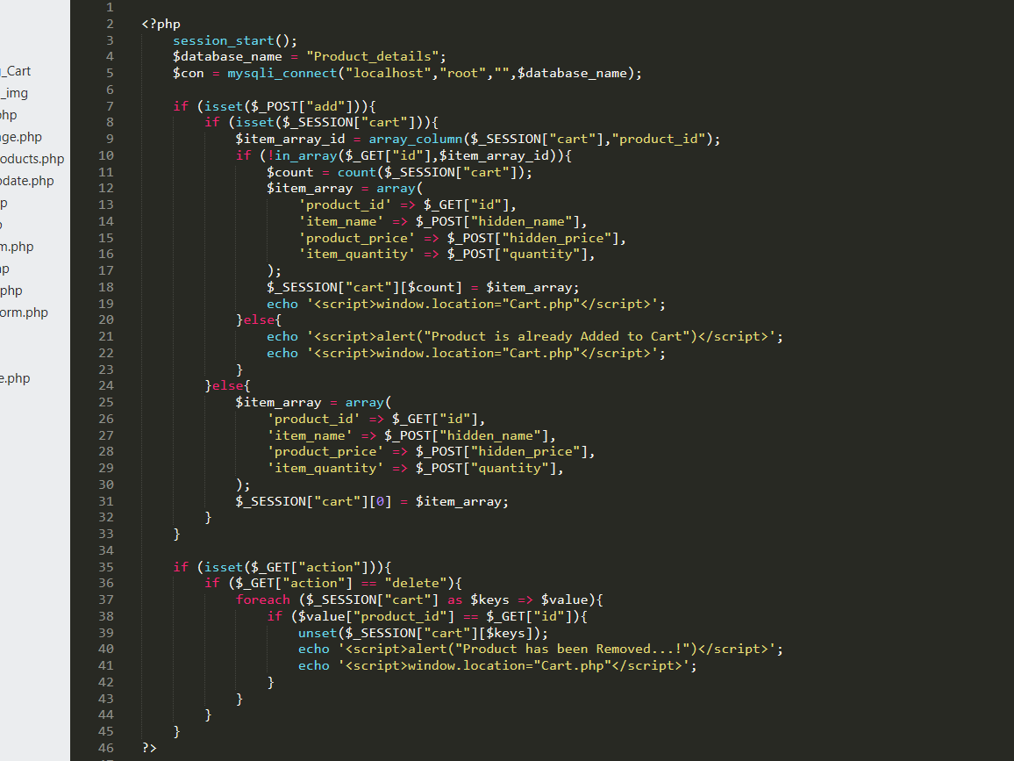

Figure 21: Database_connection_cart

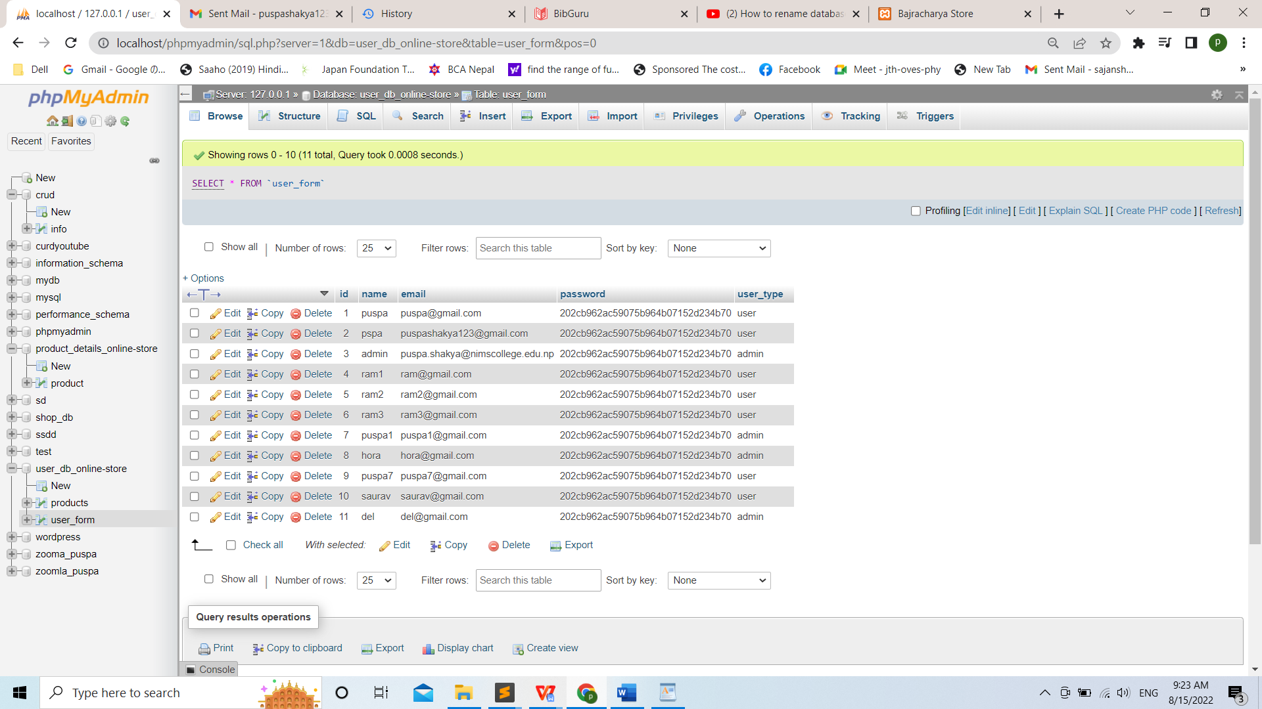

Figure 22: Datebase_of_user-type

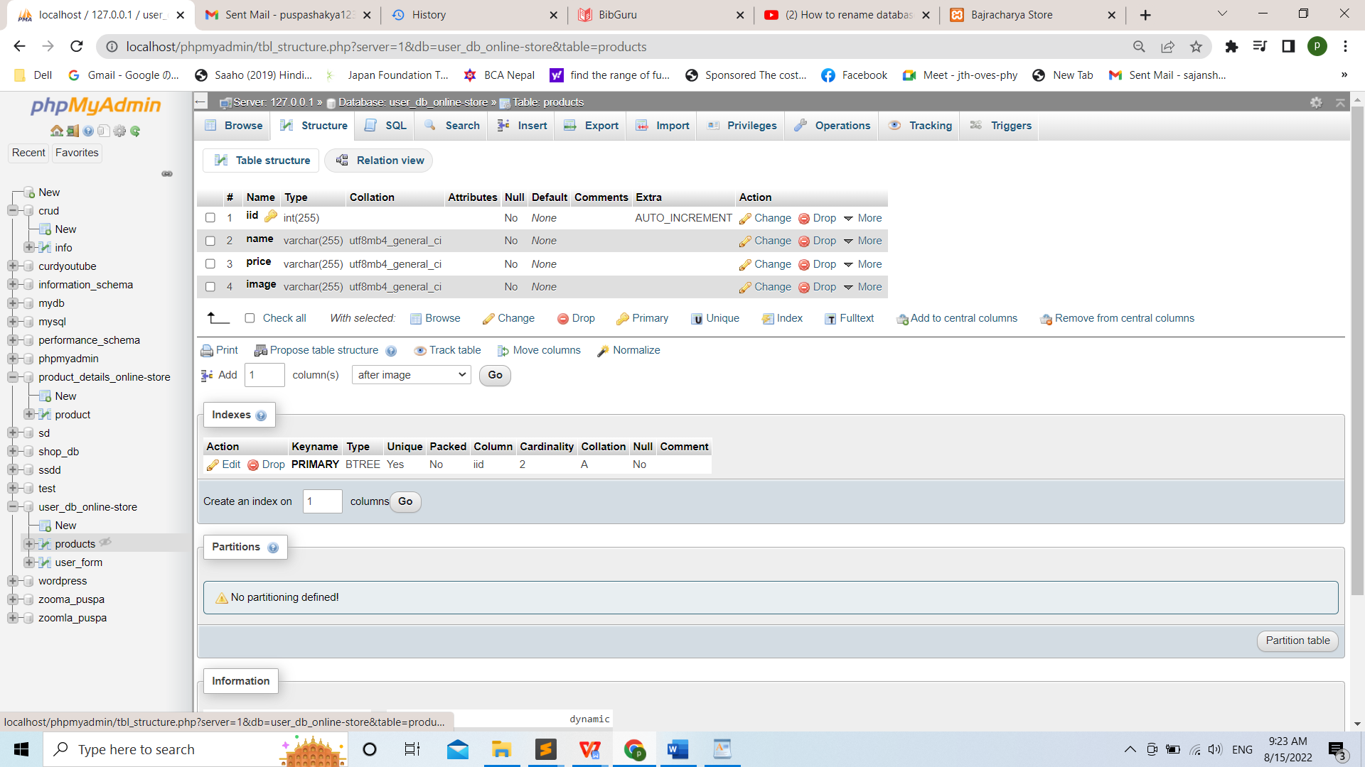

Figure 23: Database_product

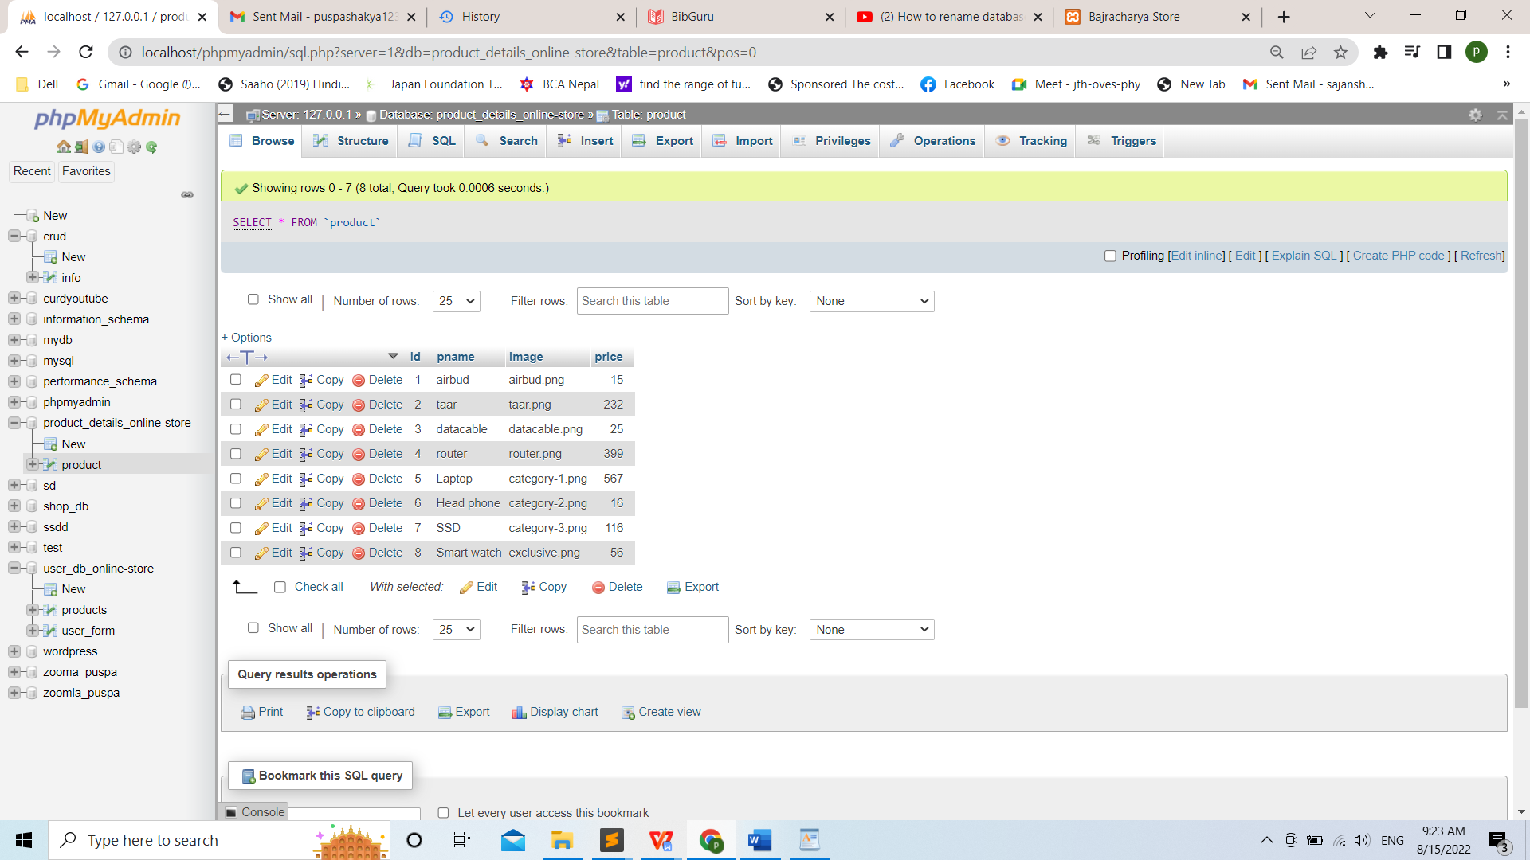

Figure 24: Database_user_cart

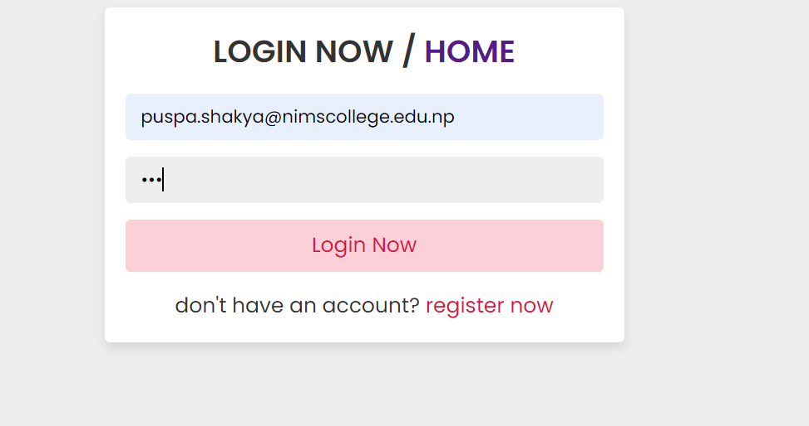

Figure 25: Login_page

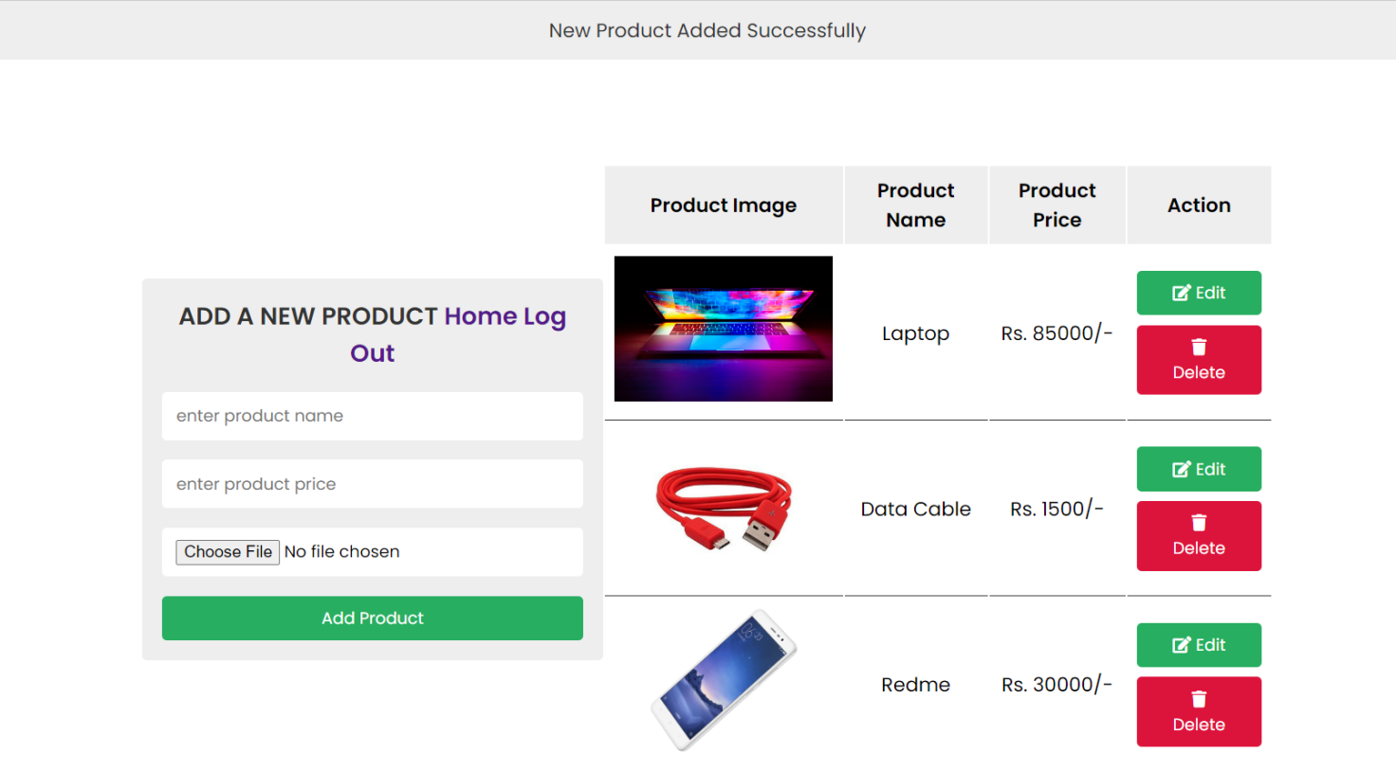

Figure 26: Admin_page-CRUD

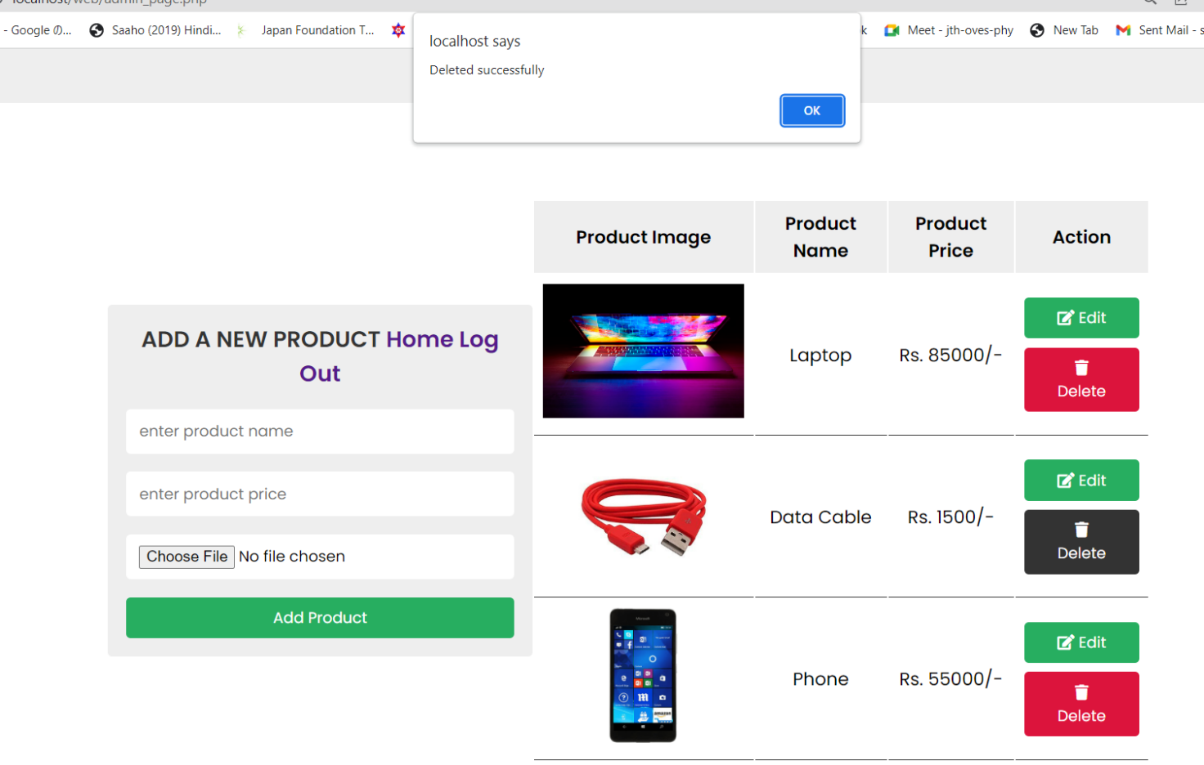

Figure 27: Admin_page_delete

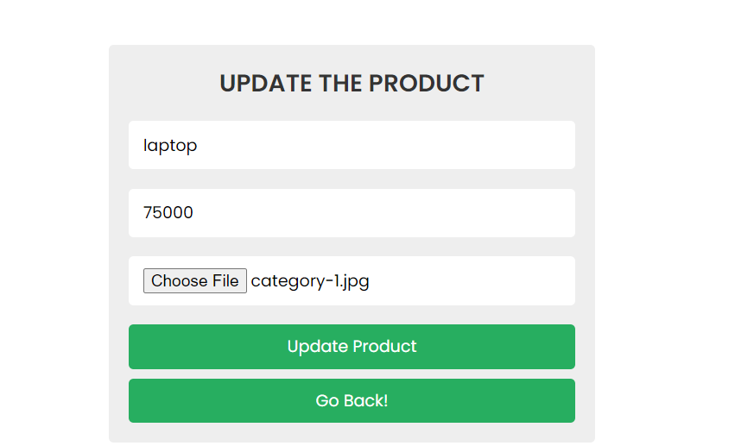

Figure 28: Admin_update-page

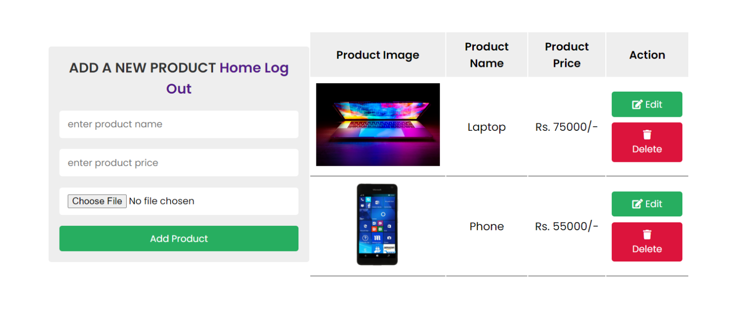

Figure 29: admin_page-after_updated

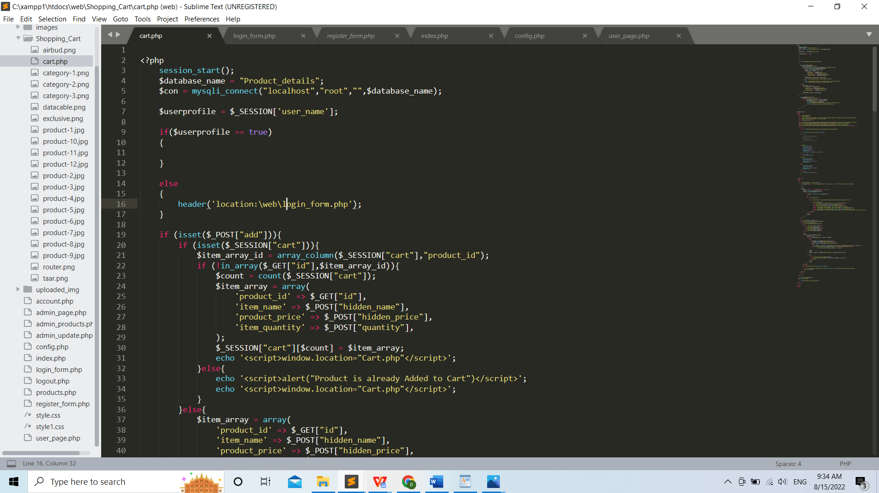

Figure 30: Cart_code-php_code-i

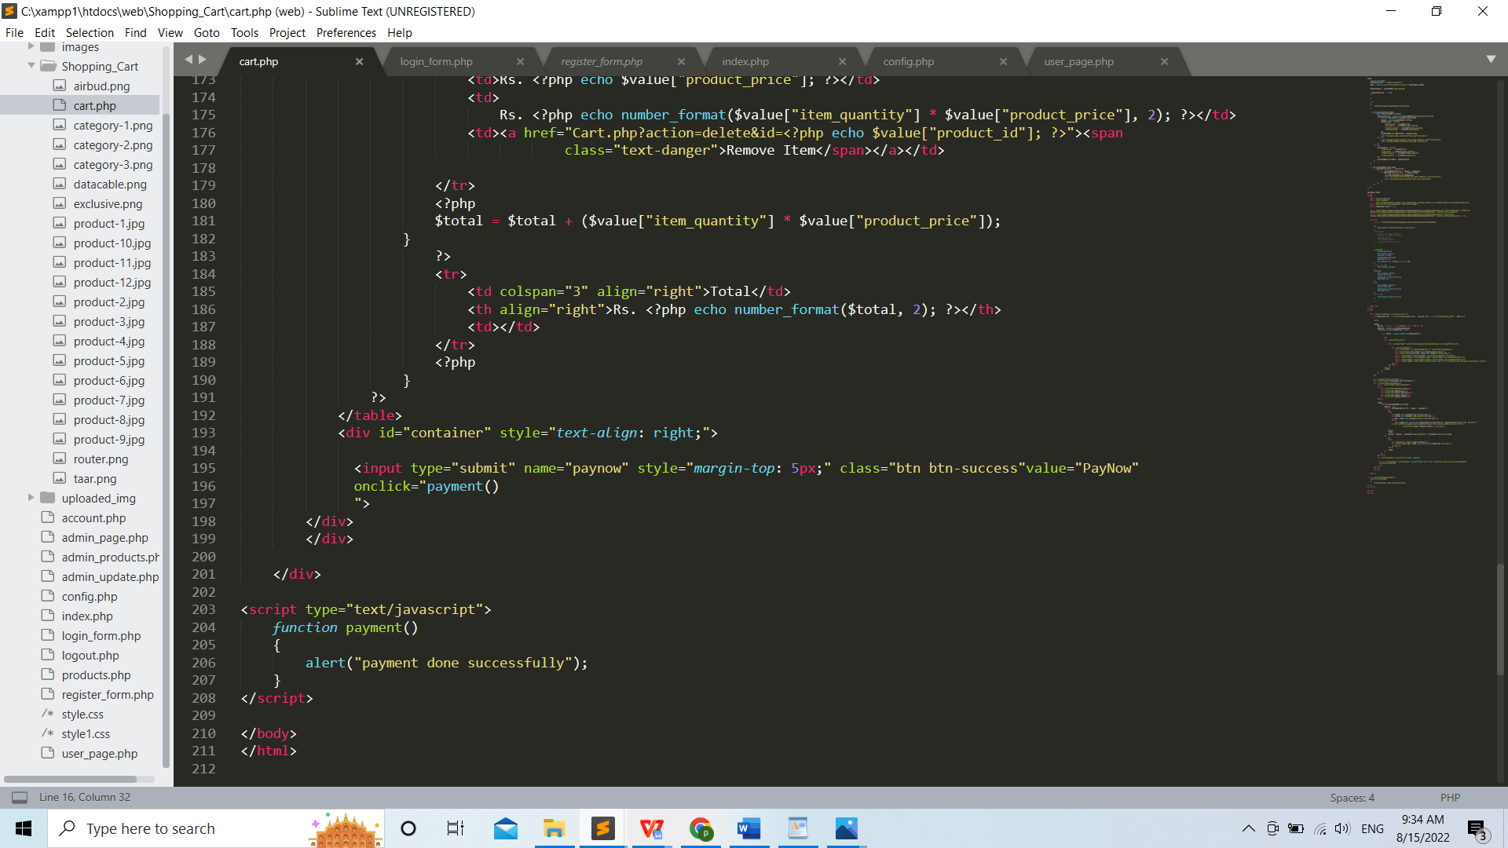

Figure 31: Cart_code-php_code-ii

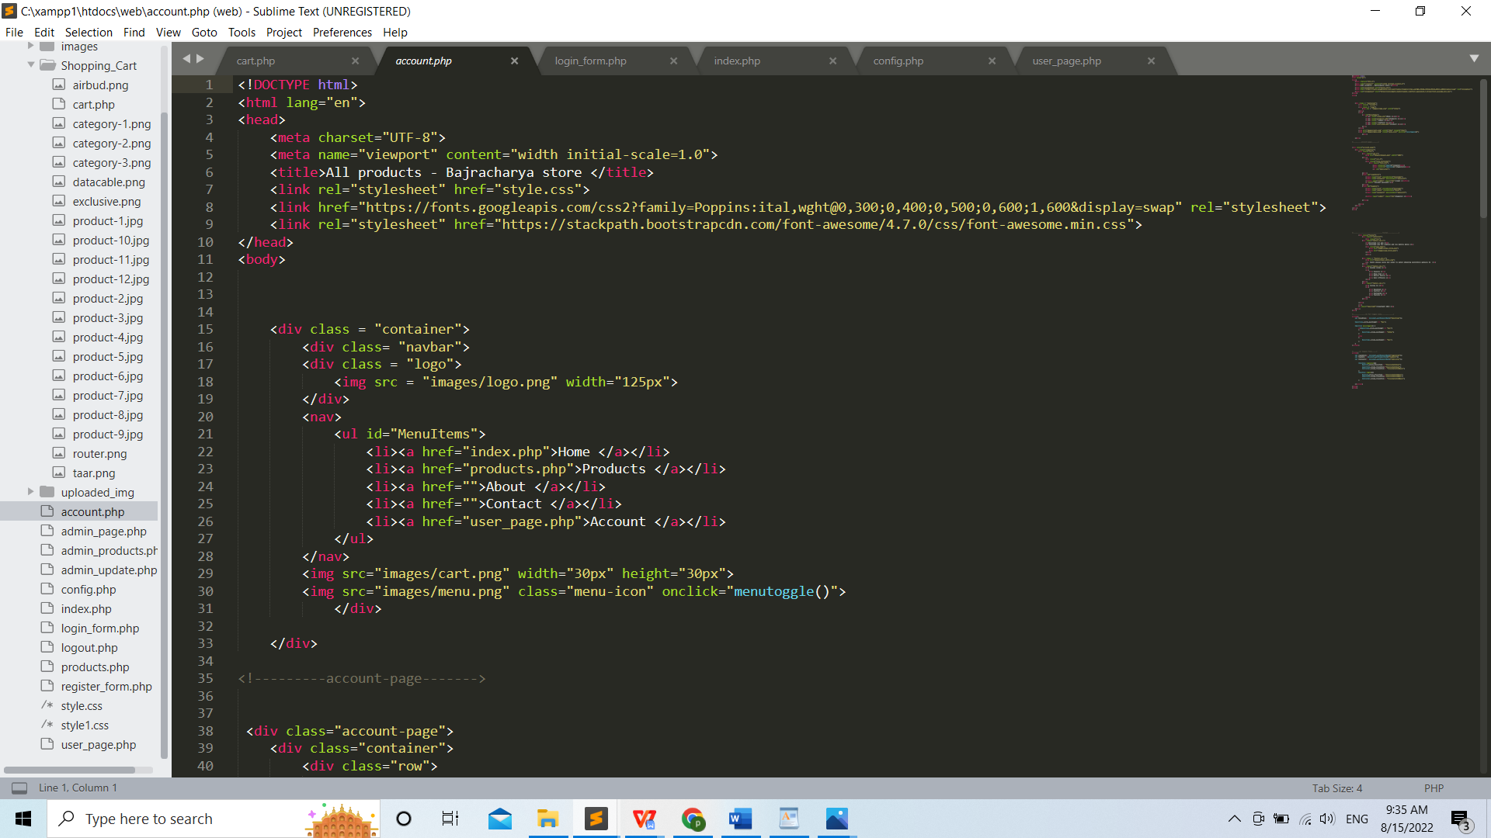

Figure 32: Account_php_code-i

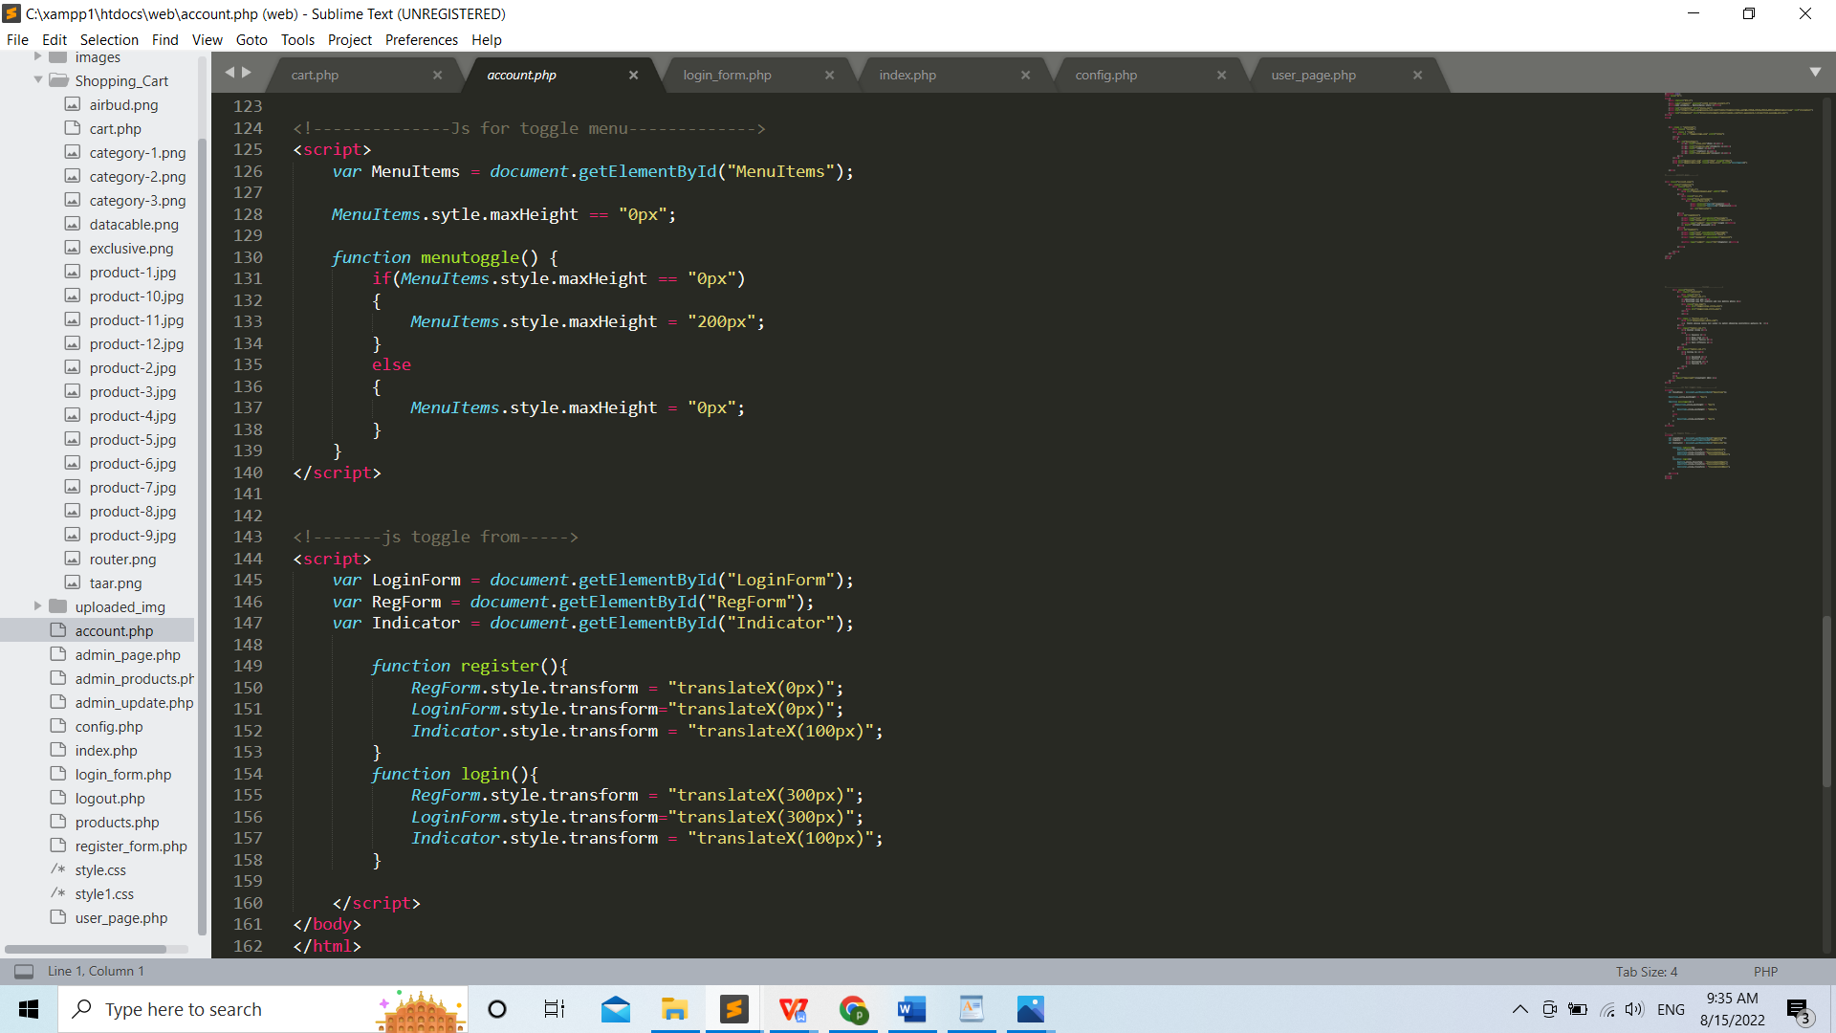

Figure 33: Account_php_code-ii

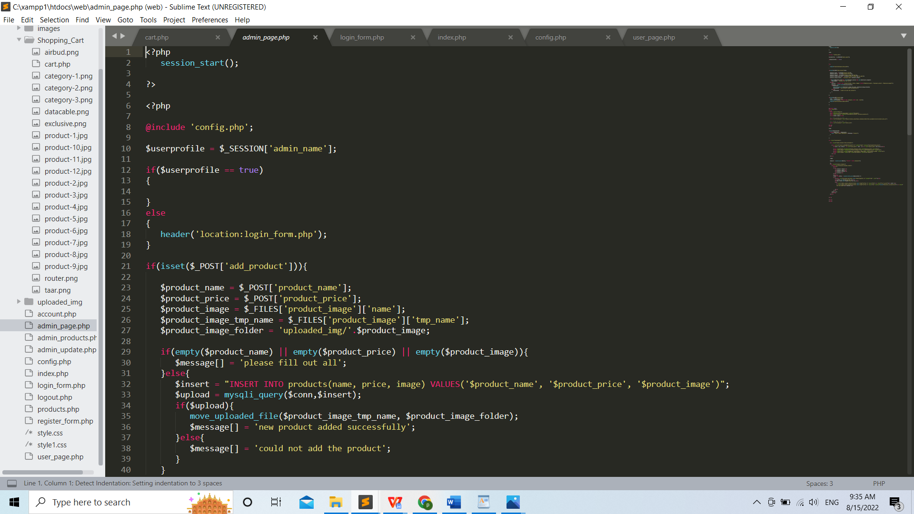

Figure 34: Admin_page_php-code-i

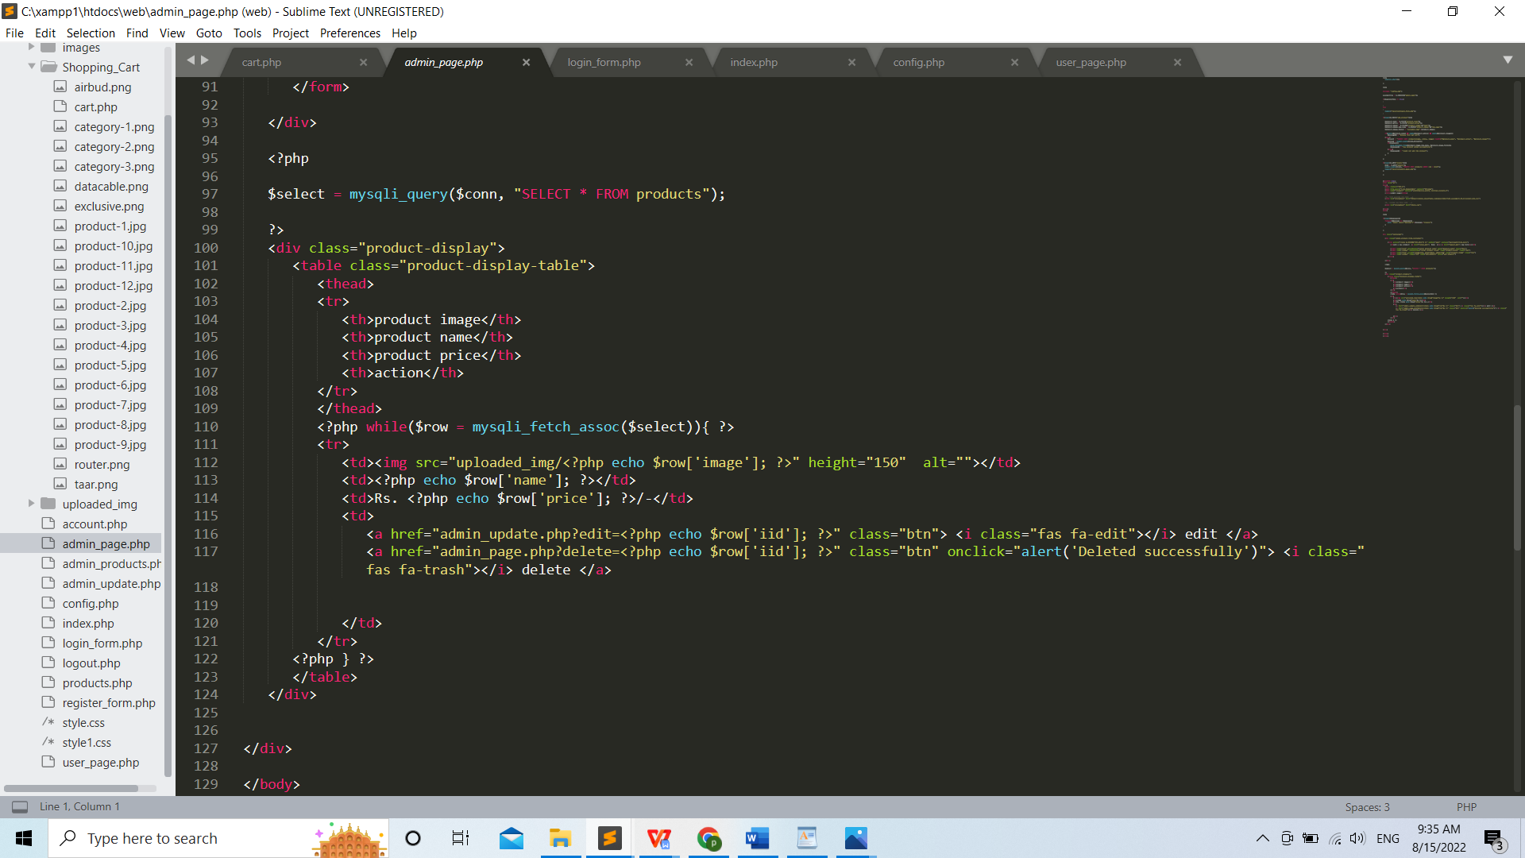

Figure 35: Admin_page_php-code-ii

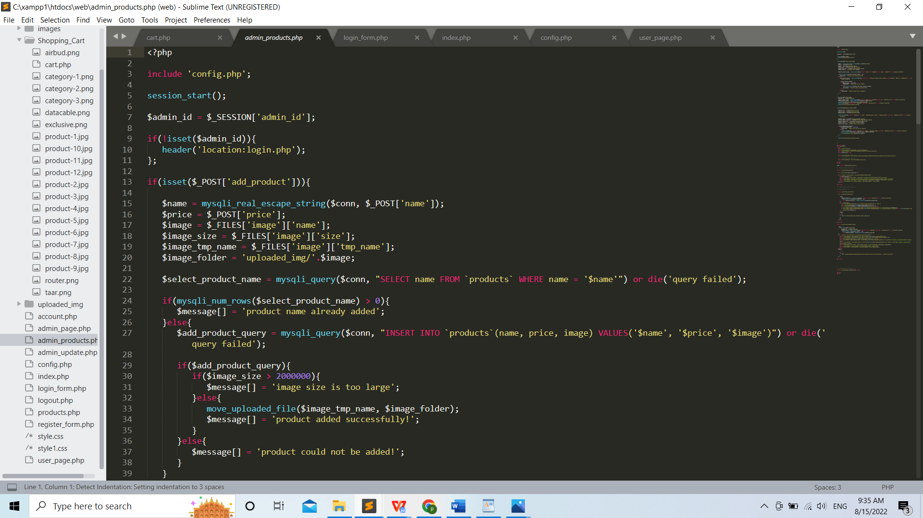

Figure 36: Admin_product_php-code-i

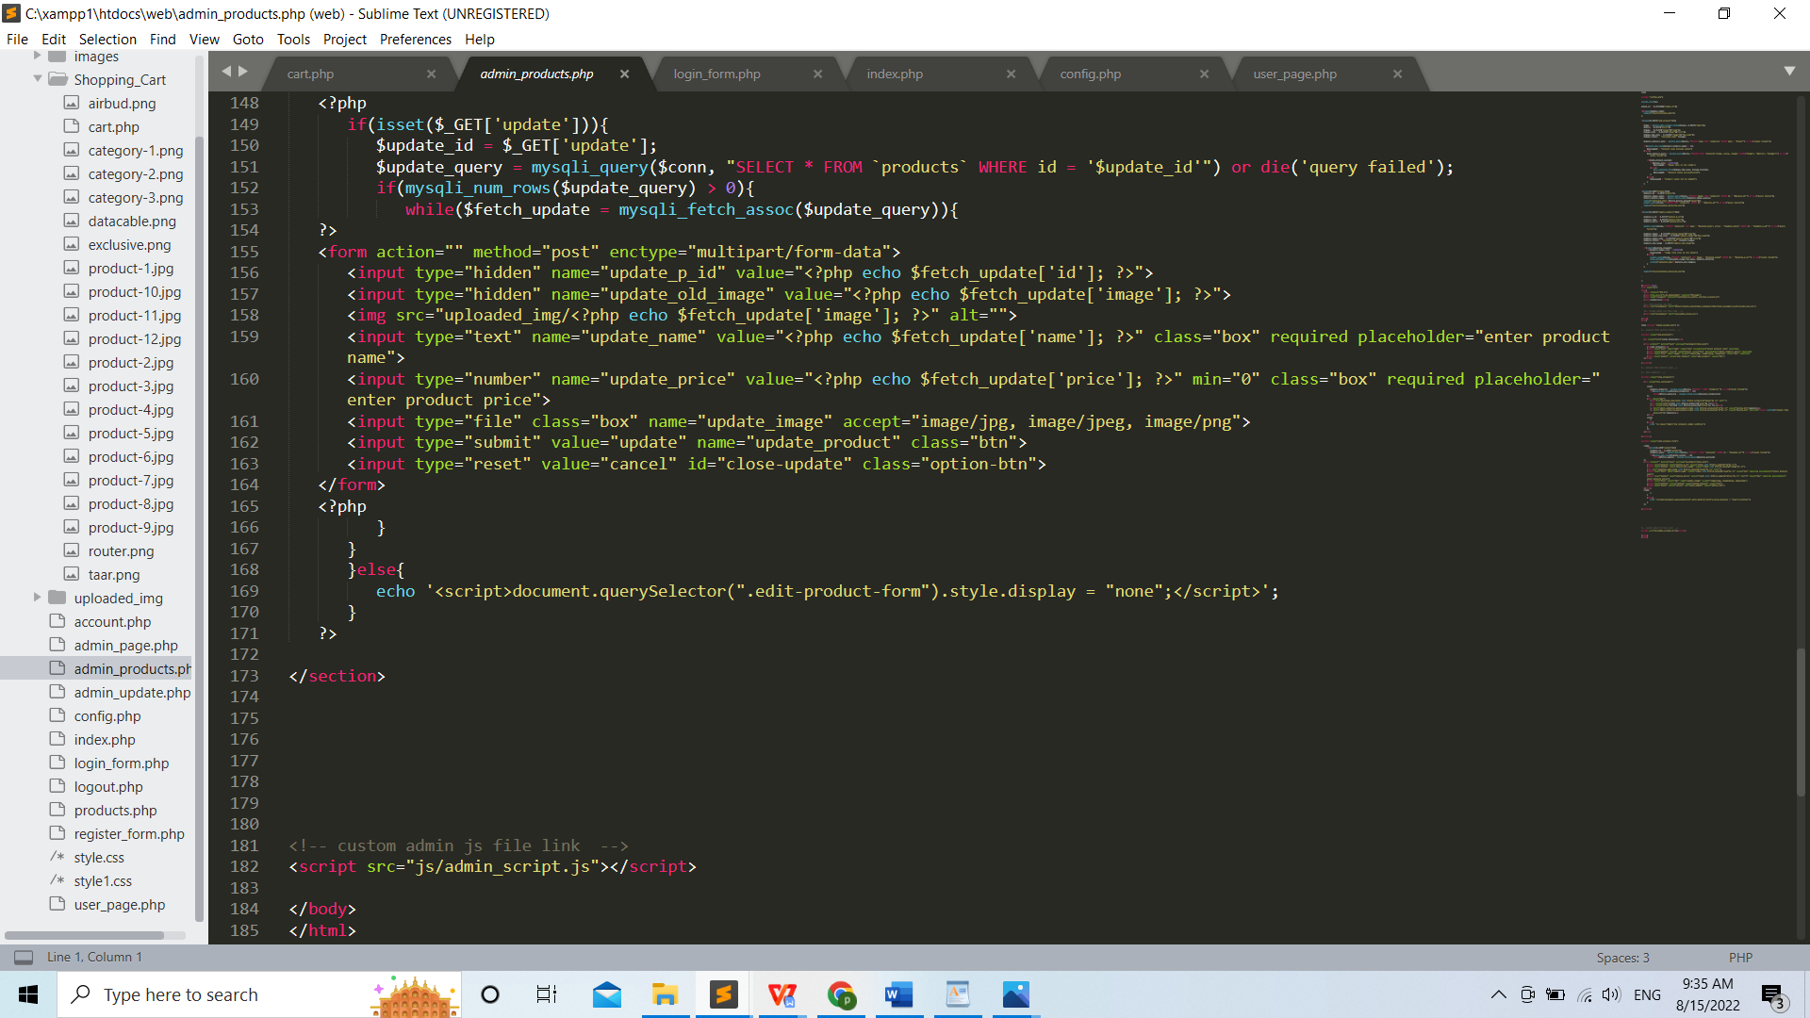

Figure 37: Admin_product_php-code-ii

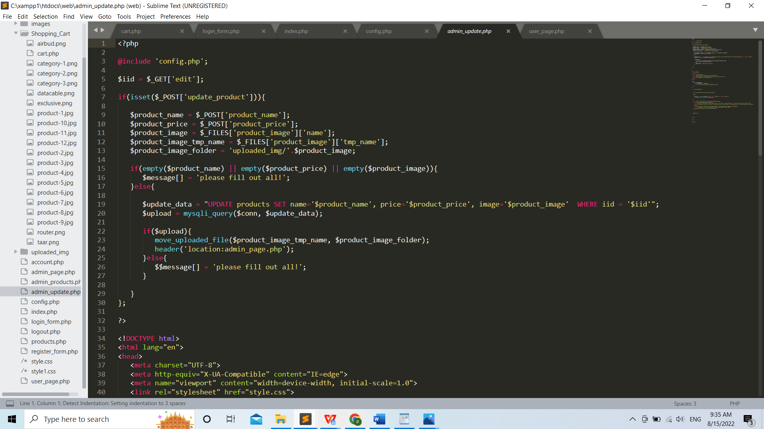

Figure 38: Admin_update_php-code-i

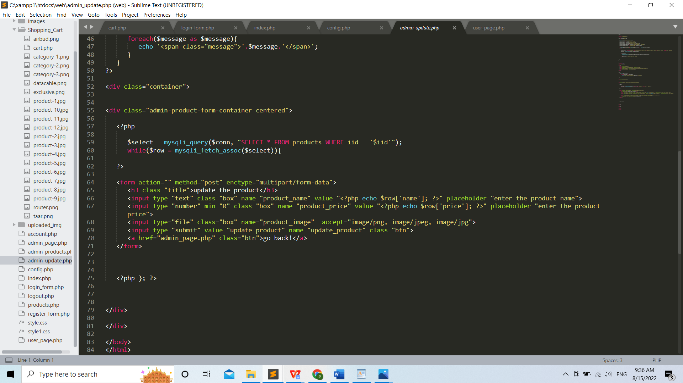

Figure 39: Admin_update_php-code-ii

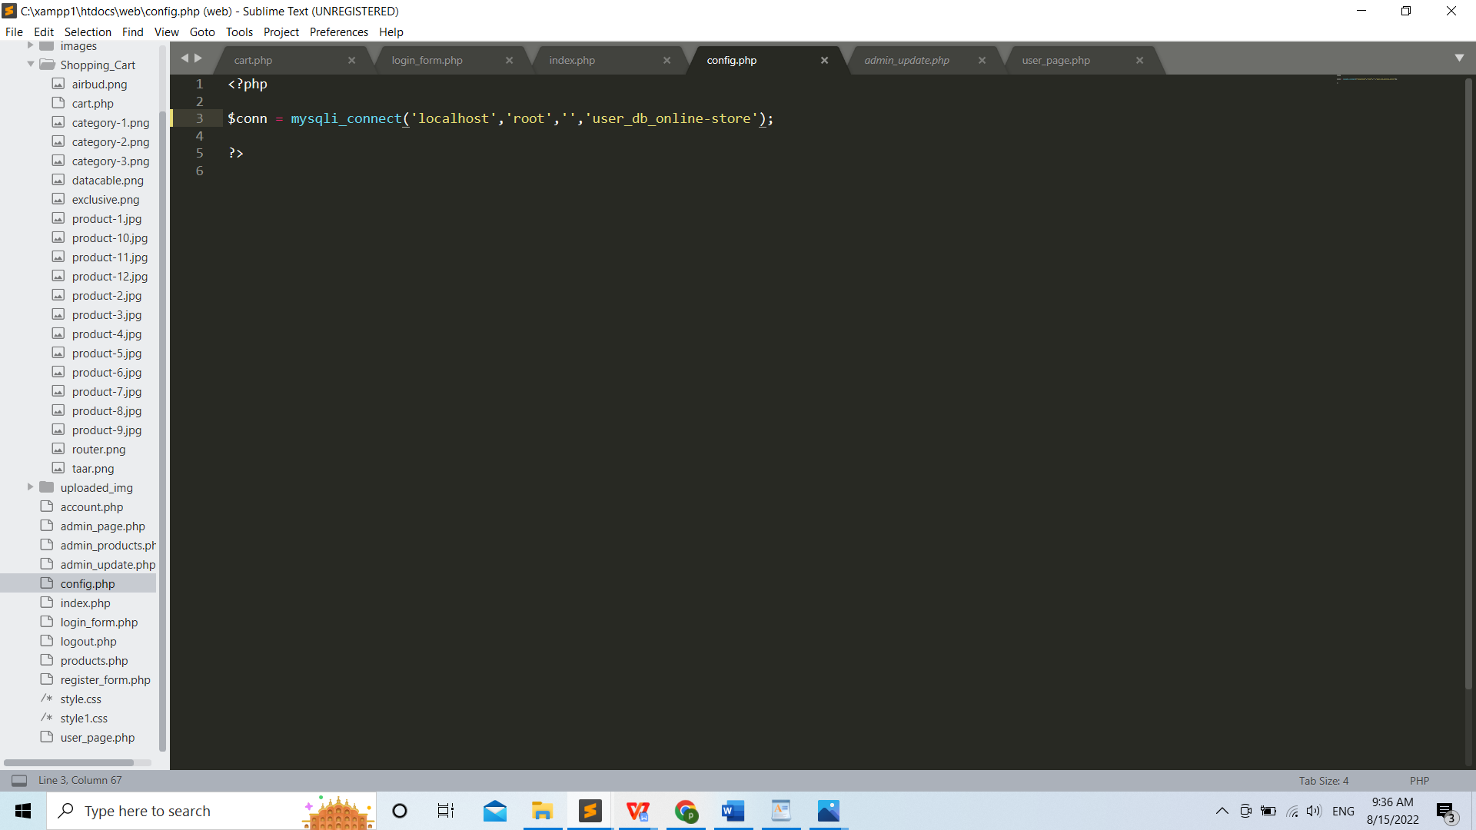

Figure 40: Configuration_code-php

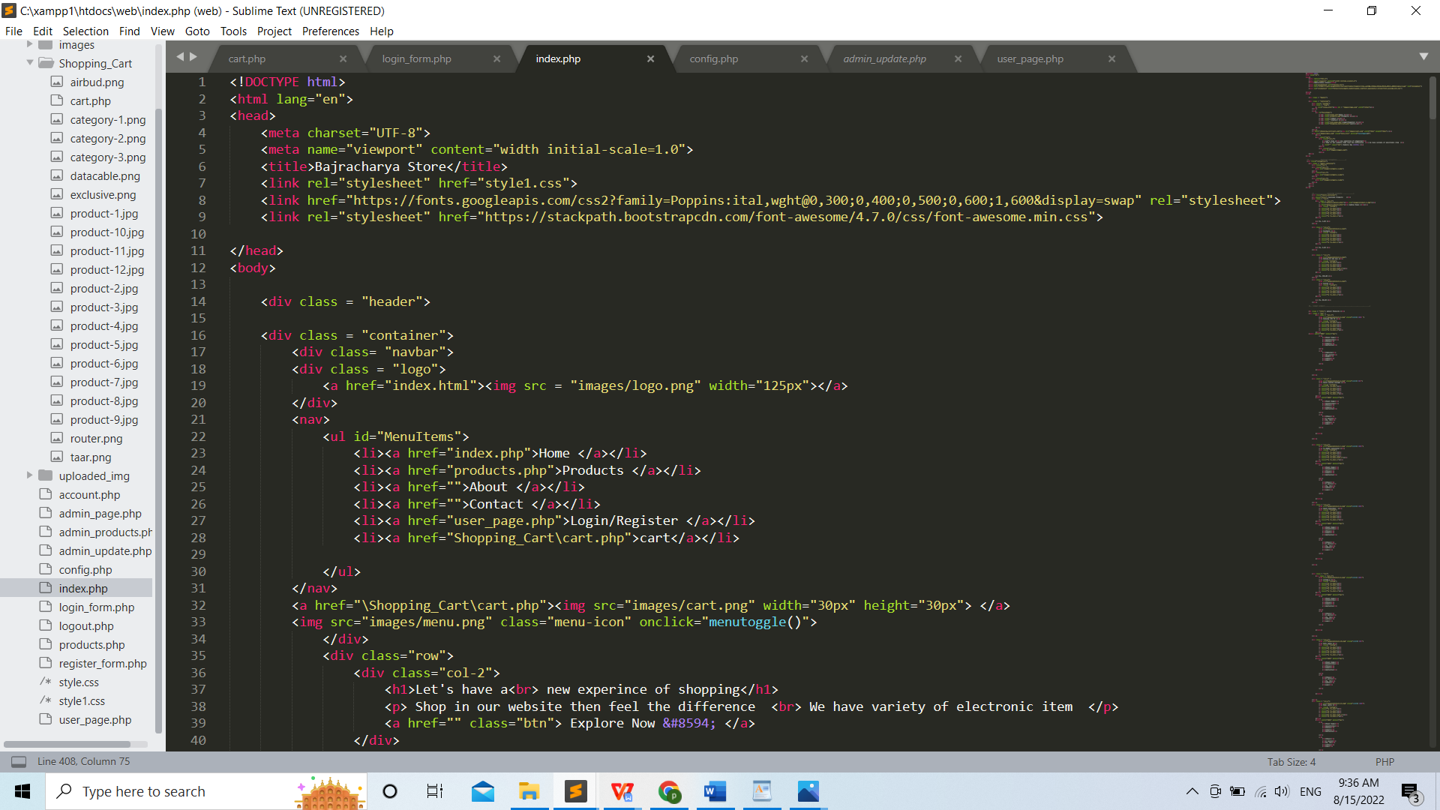

Figure 41: Index_php-code-i

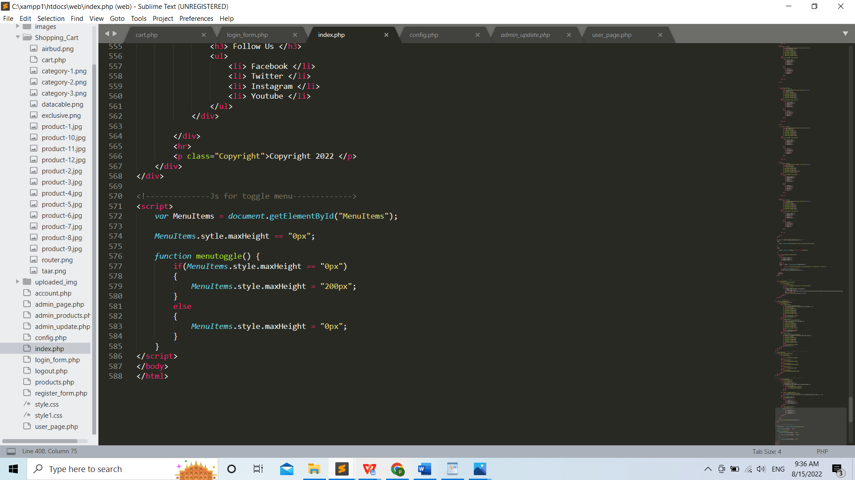

Figure 42: Index_php-code-ii

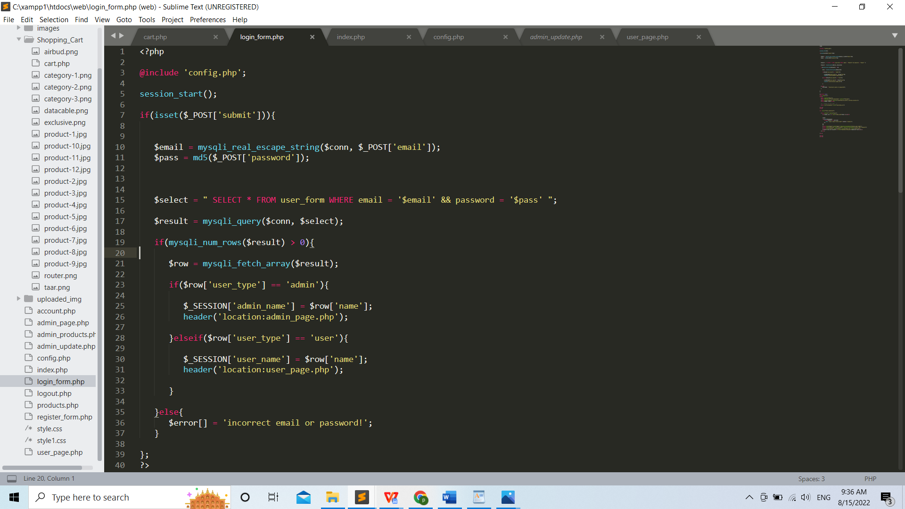

Figure 43: Login_form_php-code-i

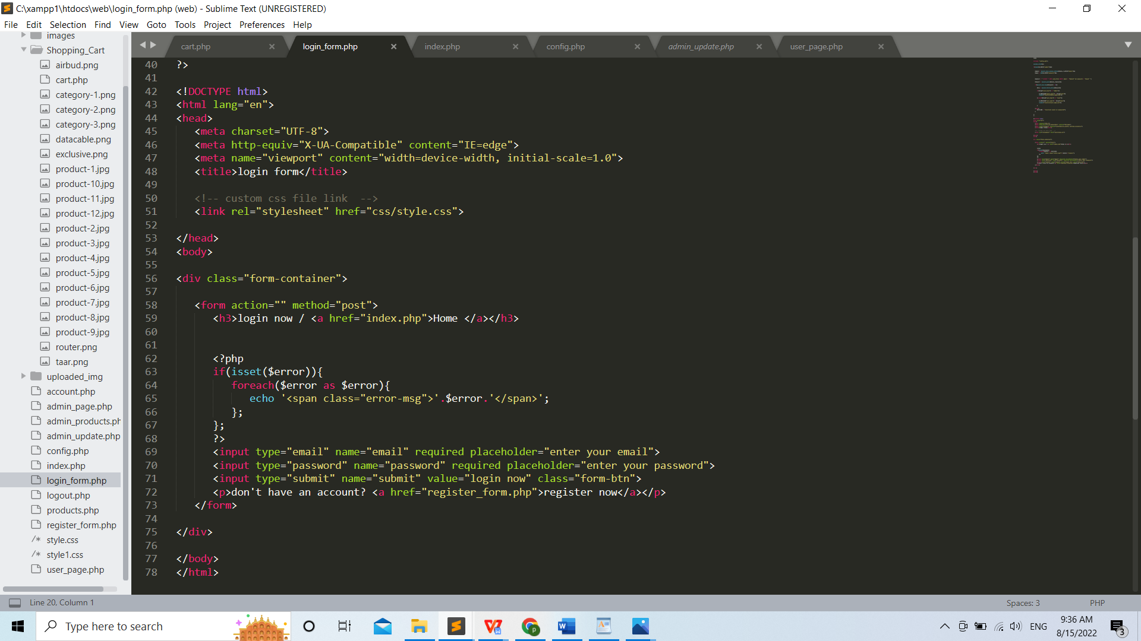

Figure 44: Login_form_php-code-ii



Figure 45: Login_from_php-code-i



Figure 46: Login_from_php-code-ii

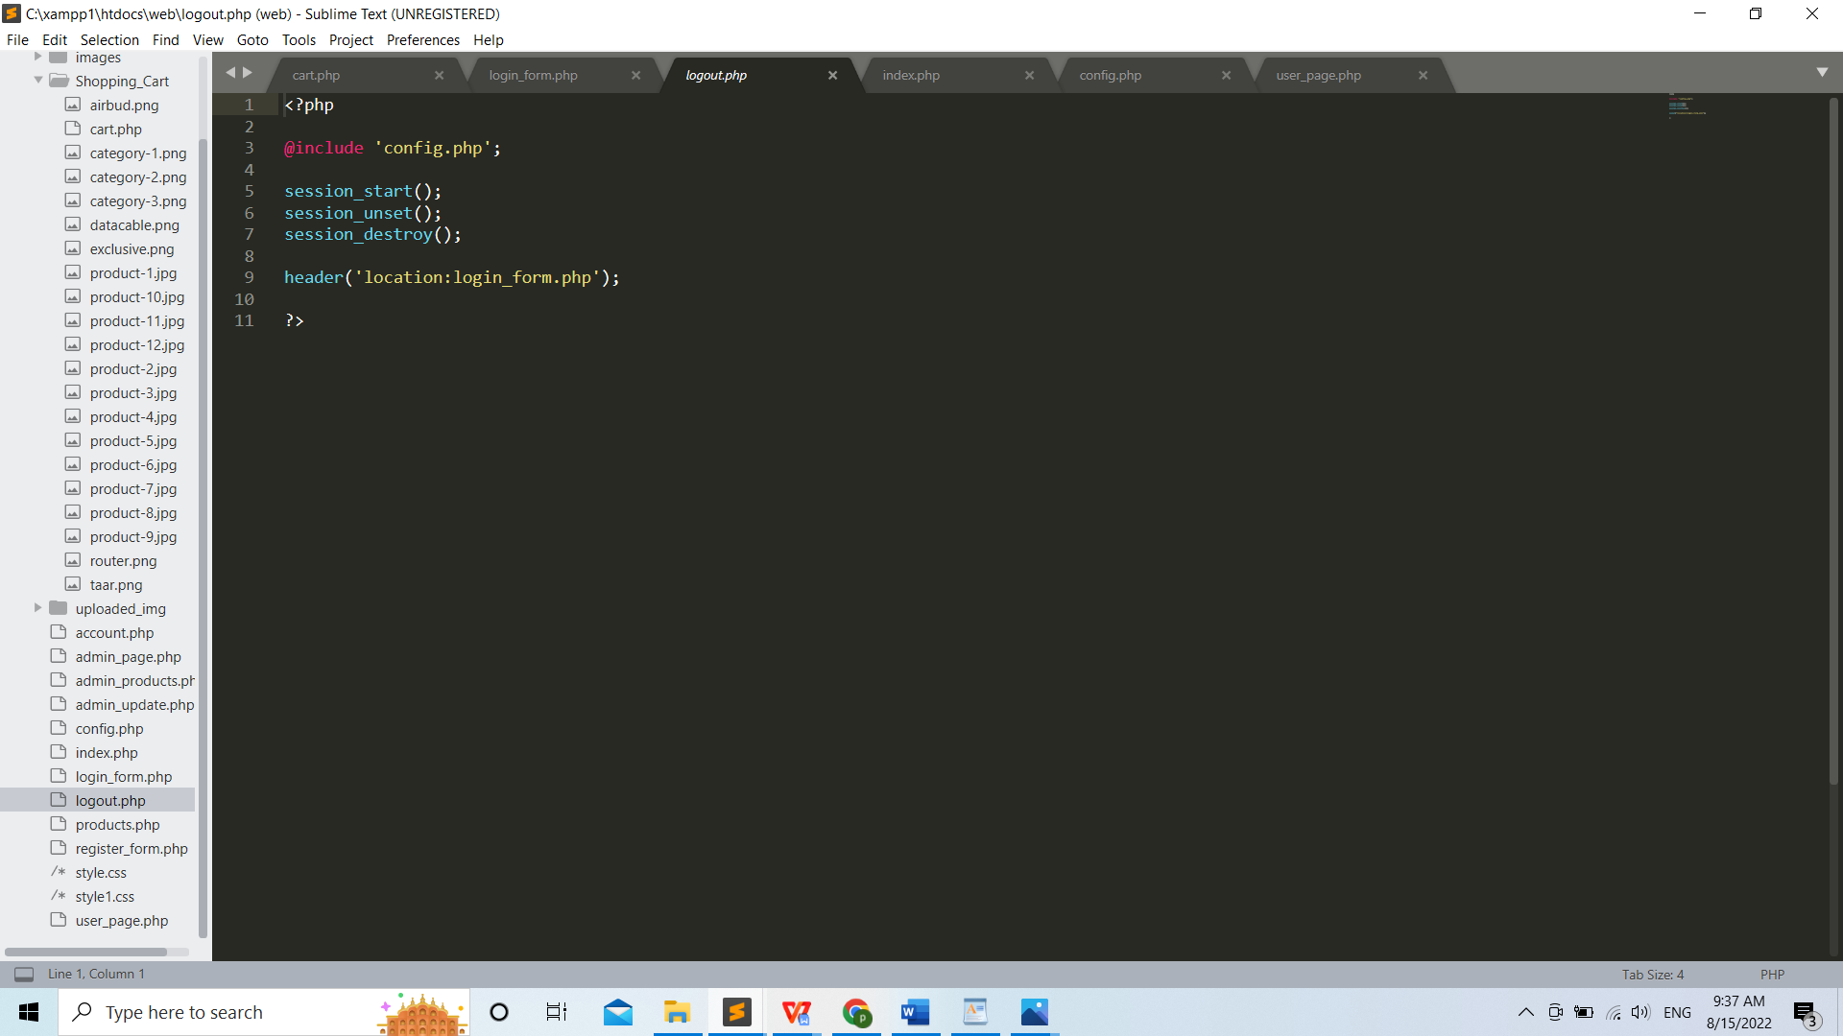

Figure 47: Logout_php-code

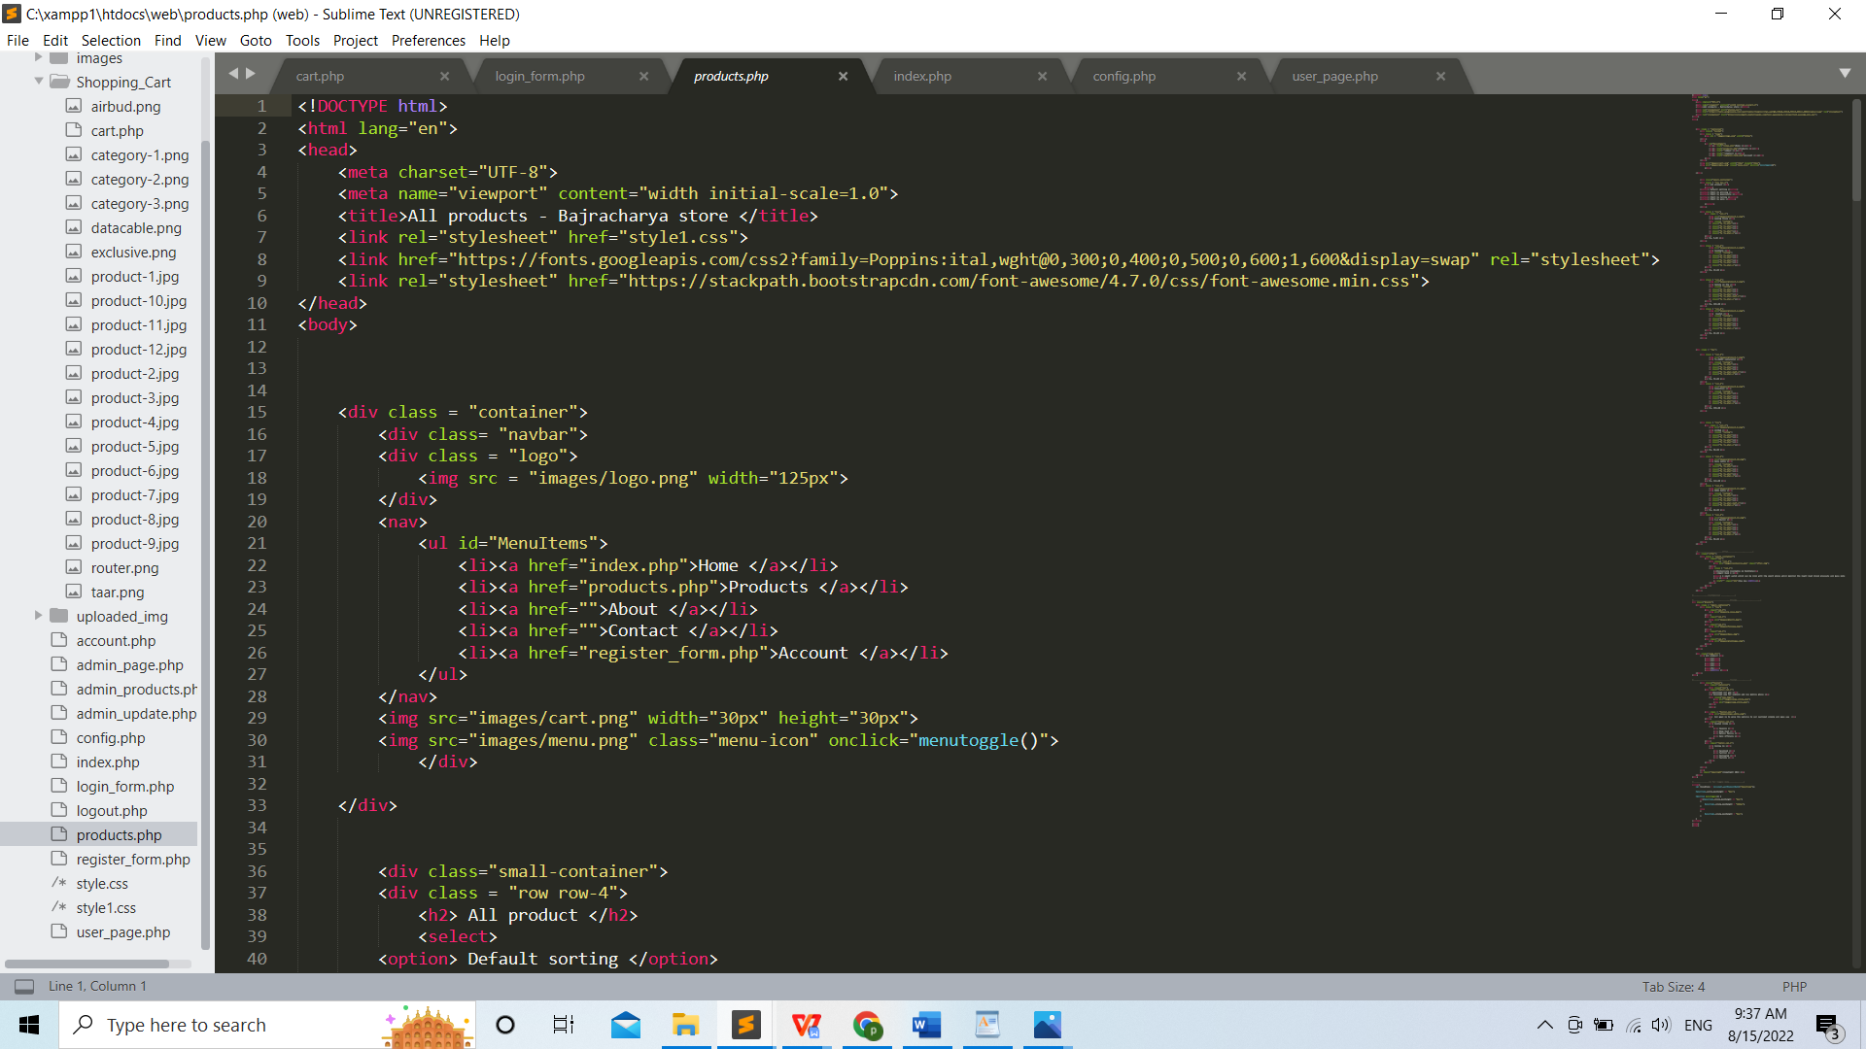

Figure 48: Product_code-php-i

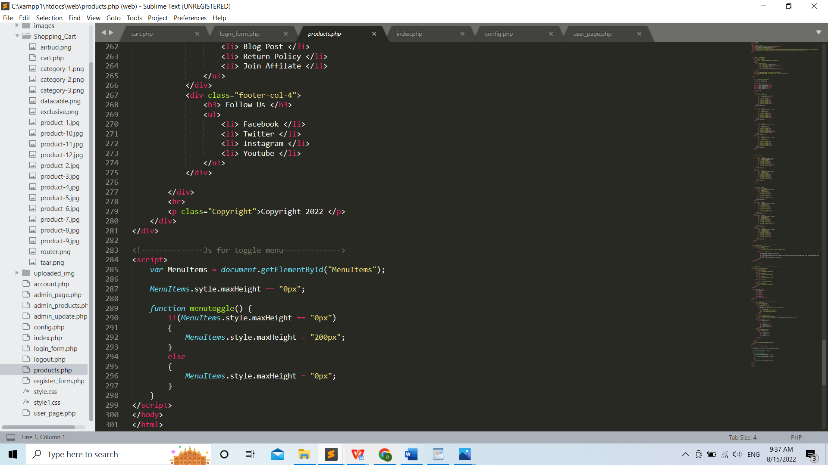

Figure 49: Product_code-php-ii

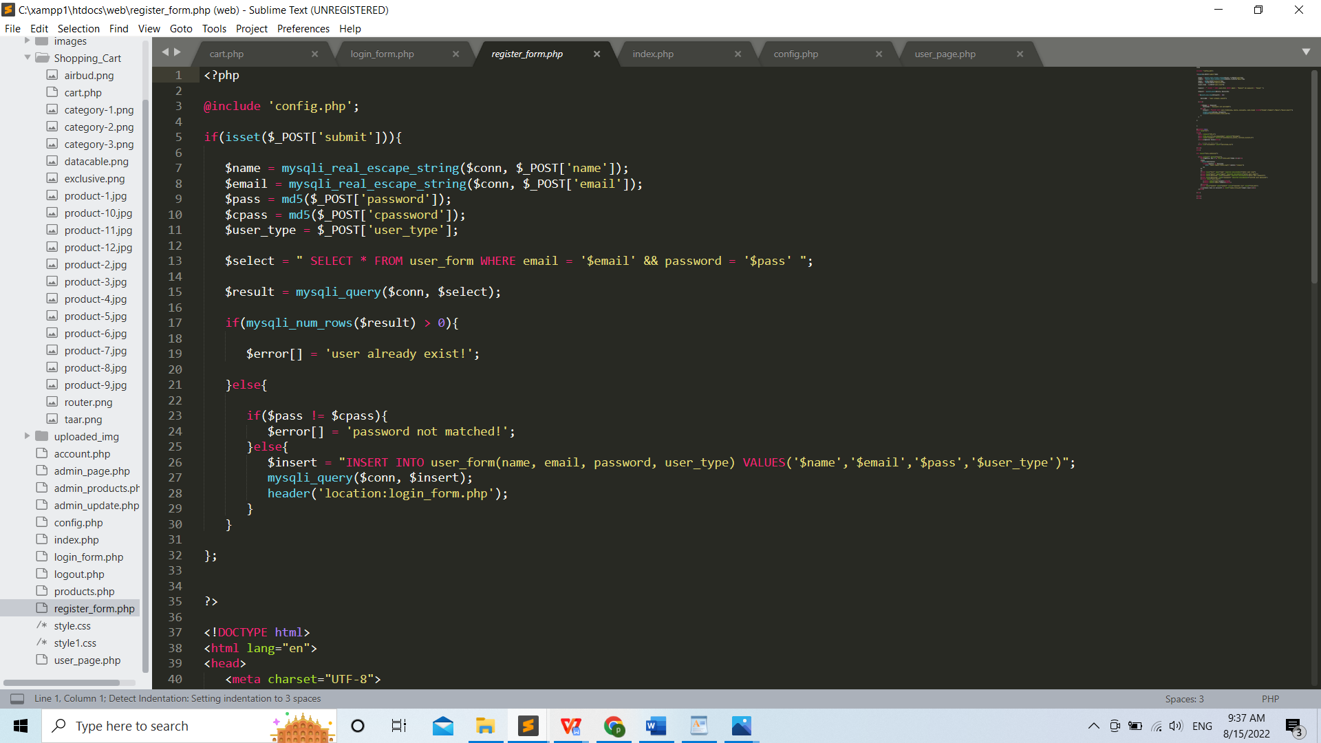

Figure 50: Register_php-code-i

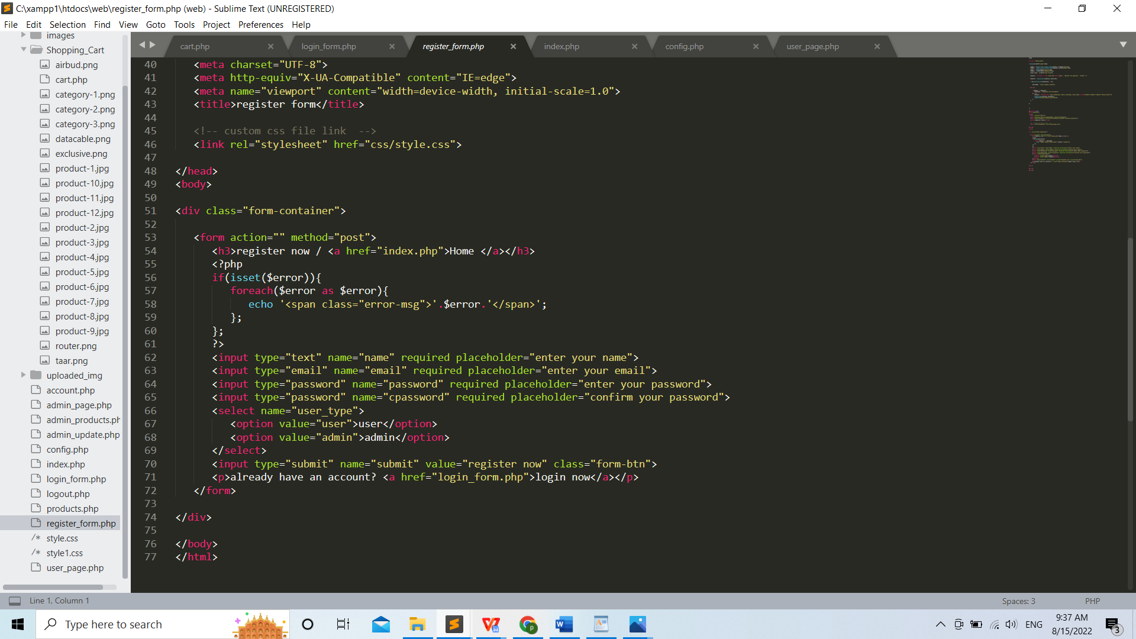

Figure 51: Register_php-code-ii

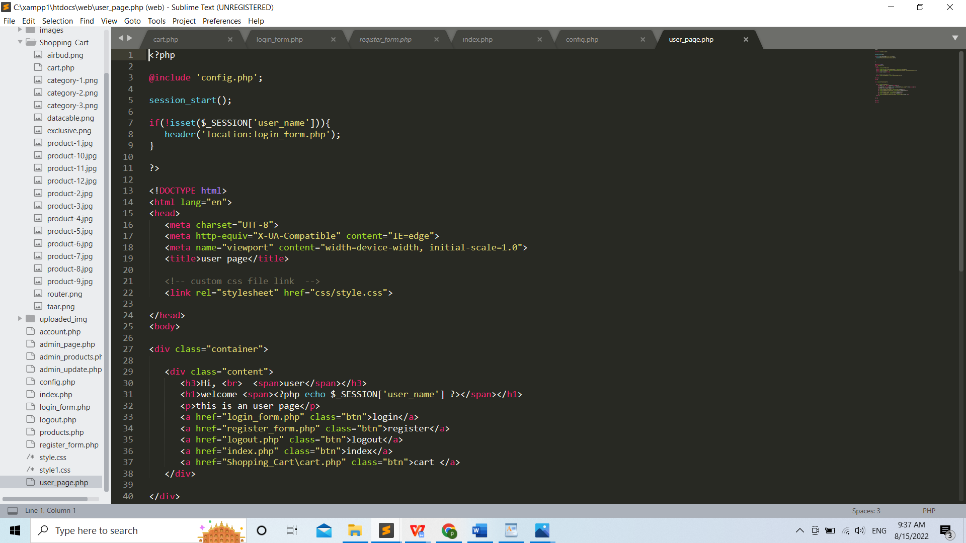

Figure 52: User_page_php-code-i

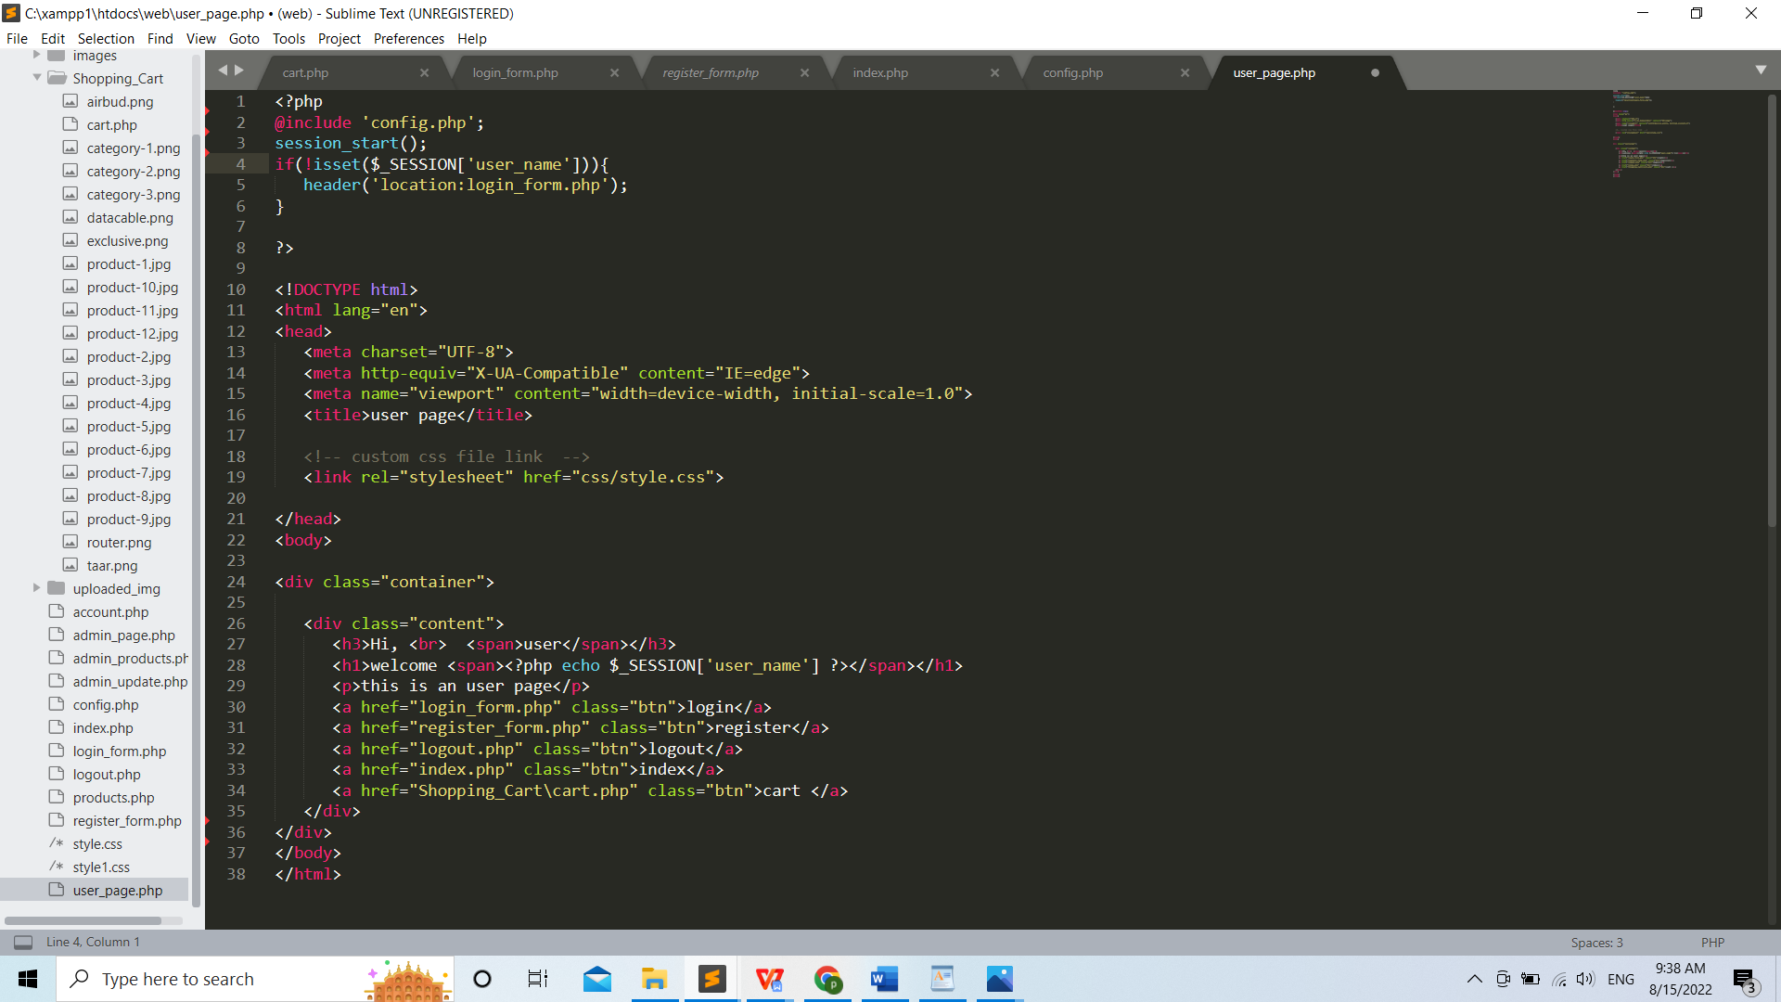

Figure 53: Register_php-code-ii

# Bibliography

[1] “Send Birthday gifts to Nepal, anniversary cakes, mother’s day gifts, father’s day gifts - send gifts online Nepal,” Thamel.com. [Online]. Available: https://thamel.com/. [Accessed: 09-Aug-2022].

[2] Nepal News, “Nepal News,” Nepalnews.com. [Online]. Available: https://nepalnews.com/. [Accessed: 09-Aug-2022].

[3] “Send Father’s Day Gifts to Nepal,” Muncha.com. [Online]. Available: https://www.muncha.com/. [Accessed: 09-Aug-2022].

[4] “Thulo.com: Online Shopping in Nepal - Online shopping store in Nepal - Best online shopping site in Kathmandu, Nepal,” Thulo.com. [Online]. Available: https://thulo.com/. [Accessed: 09-Aug-2022].

[5] “Foodmandu: Food delivery service in Kathmandu,” Foodmandu Main, 12-Nov-2017. [Online]. Available: https://foodmandu.com/. [Accessed: 09-Aug-2022].

[6] “Online shopping in Nepal,” Sastodeal.com. [Online]. Available: https://www.sastodeal.com/. [Accessed: 09-Aug-2022].

[7] “ESewa,” Com.np. [Online]. Available: https://esewa.com.np/#/home. [Accessed: 09-Aug-2022].

[8] Pathao, “Pathao Nepal - #1 Platform for All Services online cab booking services,” Pathao Nepal, 01-Dec-2019. [Online]. Available: https://pathao.com/np/. [Accessed: 09-Aug-2022].

[9] “Gsmarena.com - mobile phone reviews, news, specifications and more,” Gsmarena.com. [Online]. Available: https://www.gsmarena.com/. [Accessed: 09-Aug-2022].

[10] “Laptop Mag,” LaptopMag. [Online]. Available: https://www.laptopmag.com/uk. [Accessed: 09-Aug-2022].

[11] Researchgate.net. [Online]. Available: https://www.researchgate.net/publication/340072267_Online_Shopping_in_Nepal_Preferences_and_Problems. [Accessed: 09-Aug-2022].

[12] Researchgate.net. [Online]. Available: https://www.researchgate.net/publication/296846134_Online_Shopping_In_India_An_Enquiry_of_Consumers_World. [Accessed: 09-Aug-2022].

[13] Researchgate.net. [Online]. Available: https://www.researchgate.net/publication/354535608_Customer%27s_Satisfaction_via_Online_Shopping_Environment_The_Case_of_China. [Accessed: 09-Aug-2022].

[14] M. A. Rahman, M. A. Islam, B. H. Esha, N. Sultana, and S. Chakravorty, “Consumer buying behavior towards online shopping: An empirical study on Dhaka city, Bangladesh,” Cogent bus. manag., vol. 5, no. 1, p. 1514940, 2018.

[15] “Online shopping in Nepal,” Com.np. [Online]. Available: https://www.daraz.com.np/. [Accessed: 09-Aug-2022].

[16] H. Rai, “Daraz Nepal - company analysis, net worth, history, success, yearly revenue,” Earnfrombusiness.com, 25-Dec-2021.

[17] “Environmental analysis of US online shopping,” Mit.edu. [Online]. Available: https://ctl.mit.edu/pub/thesis/environmental-analysis-us-online-shopping. [Accessed: 09-Aug-2022].

[18] H.F. Morano, “From A to Z: The complete history of Amazon.com,” EcomCrew, 30-Oct-2020.

[19] Historyofinformation.com. [Online]. Available: <https://www.historyofinformation.com/detail.php?entryid=4528>. [Accessed: 15-Aug-2022].

1. “A short history of the Web,” CERN. [Online]. Available: <https://home.cern/science/computing/birth-web/short-history-web>. [Accessed: 15-Aug-2022].
2. “Amazon: Complete guide — history, products, founding, and more,” History-Computer, 04-Jan-2021. [Online]. Available: <https://history-computer.com/amazon-history/>. [Accessed: 15-Aug-2022].

[22] Diwakar, “Rise of e-commerce in Nepal: A pioneer explains,” admin, 28-Aug-2020. [Online]. Available: <https://english.onlinekhabar.com/rise-of-e-commerce-in-nepal-a-pioneer-explains.html>. [Accessed: 15-Aug-2022].